Annie Lee (Keller) Washington

November 6, 1936 – April 20, 2018

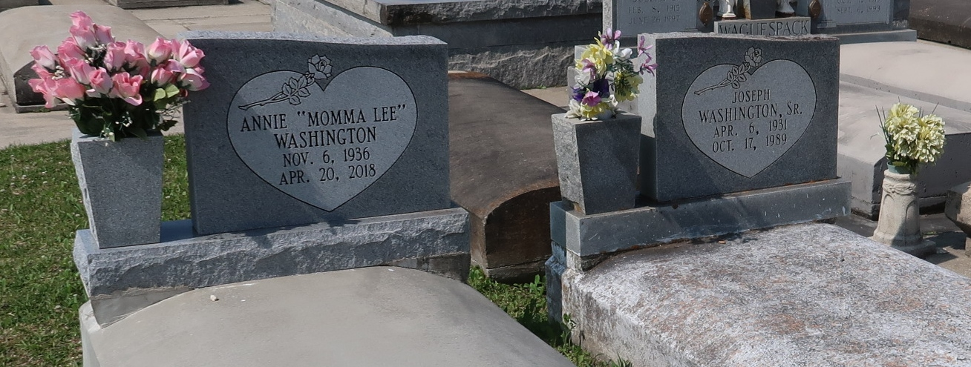

ANNIE WASHINGTON

A native of Vacherie and a former resident of Paulina. She passed away at her daughter's residence in Gramercy at 7:21 a.m. Friday, April 20, 2018. She was 81.

Visiting at St. Joseph's Catholic Church in Paulina on Saturday, April 28, 2018 from 9:30 a.m. until Mass of Christian Burial at 11:00 a.m. Interment in church cemetery.

Survived by four daughters: Marlene (Hugh) Pittman, Linda and Lorraine Washington and Betty (Gregory) Clayton. Three sons: Larry (Mary) Washington, Stacy Washington and Barbick (Raven) Washington. Two sisters: Marion Simon and Carolyn Keller. A brother: Clovis (Gloria) Keller. Twenty grandchildren, thirty-nine great-grandchildren, numerous aunts, uncles, nieces, nephews, cousins, sisters and brothers-in-law, other relatives and friends.

Preceded in death by her parents: Bernard Keller, Sr. and Luctria Lemieus Keller. Her husband, Joseph Washington, Sr. Two daughters: Juliana Washington and LeeAnn Fluence. A son: Barry Washington. Three brothers: Ronald, Raymond and Bernard Keller, Jr.

BRAZIER-WATSON FUNERAL HOME IN CHARGE OF ARRANGEMENTS. Visit us at [www.brazierwatson.com](http://www.brazierwatson.com/) to sign our guest book.

Published by The Advocate (Baton Rouge, LA) from Apr. 26 to Apr. 28, 2018.