Ada M. (Martin) Wilday

August 26, 1927 – April 27, 2005

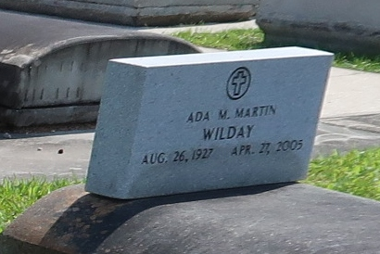

Ada Martin Wilday, age 77, a retired school bus driver in Jefferson Parish, died Wednesday April 27, 2005, at West Jefferson Hospital. She was born in Grand Point, LA and lived in Marrero for the past 50 years. She was a graduate of Lutcher High School.

Survivors include one daughter, Suzanne Wilday, one grandson, Val Wilday, and two great granddaughters, Valerie Johnson and Danielle Johnson, one brother, Percy Martin and two sisters, Anna Mae Bourgeois and Doris St. Pierre.

Ada was preceded in death by her husband, Eddie, four sisters, Lil Duhe, Rose Mae Monier, Alice Keller, and Jeanne Louque, an infant brother, Volture, Jr., and deceased parents, Volture and Louise L. Martin.

A Mass of Christian Burial will be held at 11AM, Saturday, April 30, 2005, at St. Joseph Church in Paulina, LA. Visitation will be at 8AM to 11AM at the church. Father Ed Fuss, Officiating. Interment in the church cemetery. H. C. ALEXANDER FUNERAL HOME OF LUTCHER is in charge of arrangements.

Published by The Times-Picayune (New Orleans, LA) on Apr. 29, 2005.