Lewis W. Woods

August 21, 1926 – October 31, 2010

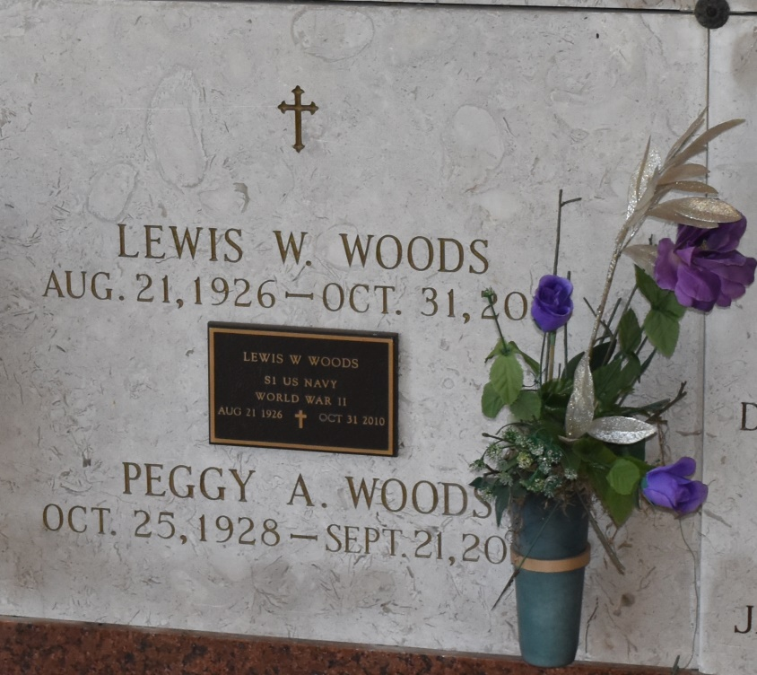

Lewis W. Woods, age 84, passed away on Sunday, October 31, 2010. He was the longtime manager of Airline Motors Restaurant in LaPlace, LA. He loved crossword puzzles, fishing with his friends and spending time with his family. He was a native and resident of Lutcher, LA. He is survived by his wife, Peggy Arceneaux Woods; sons: Thomas (Sharon), Richard (Belinda), and Alvyn (Tammy) Woods; daughters: Natalie Woods Plasters, Yvonne "Missy" Woods, and Sarah Woods; and grandchildren: Julie Napoli (Scott), Jennifer Pickett (A.J.), Taylor Spencer, Connor Plasters, Jessica Plasters, and Anna Woods. He is also survived by 6 great-grandchildren. He was preceded in death by parents, Mr. and Mrs. Alvyn L. Woods; brothers: Alvyn Woods, Jr. and Richard Woods; as well as a sister, Lirette Fullmer. Visitation will be at St. Joseph Catholic Church, Paulina, LA on Thursday, November 4, 2010 from 10:00 a.m. until 1:45 p.m. followed by a Mass of Christian Burial at 2:00 p.m. with Fr. Mark Beard, Celebrant. Entombment in St. Joseph Cemetery. ROSE LYNN FUNERAL SERVICES is in charge of the arrangements.  
  
Published in The Times-Picayune (New Orleans, LA) on November 3, 2010