Margie (Poche) Zeller
December 8, 1934 - July 29, 2024

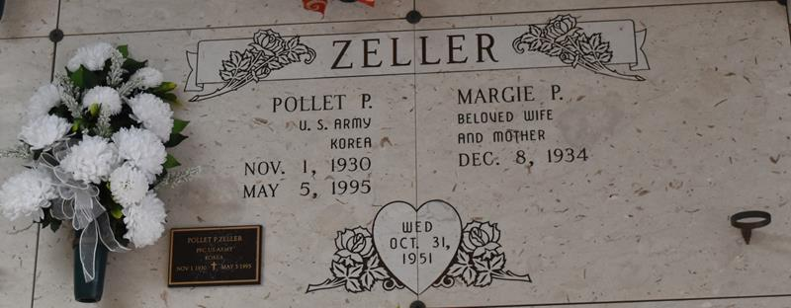

Margie Poche Zeller was born on December 8, 1934, and passed away on, Monday, July 29, 2024, at the age of 89. She was a native of Convent, LA and was a resident of Lutcher, LA. She was a loving wife, mother, grandmother, godmother, aunt, and friend. She enjoyed cooking, sewing, crafting, and gathering with family and friends. She was a member of The Catholic Daughters of America and The Altar Society of St. Joseph Church.
She is survived by her children: William "Billy" J. Zeller (Susan), Barry P. Zeller and Phyllis Z. Rodrigue (Roland); seven grandchildren; seventeen great-grandchildren; five great-great-grandchildren; and numerous nieces, nephews and cousins.
She is preceded in death by her husband, Pollet P. Zeller; son, Brent Thomas Zeller; grandson, William "Billy Boy" Zeller, Jr.; great grandson, Christian Vogel; parents, Gaston and Julie Weber Poche; brothers, Roger "Shot" Poche and Gaston "Junior" Poche, Jr. and sister, Rita Poche Zeringue.
In lieu of flowers, Masses or donations to St. Jude Children’s Hospital, 501 St. Jude Place, Memphis, TN 38105, preferred.
Relatives and friends are invited to attend the Visitation and Funeral Mass at St. Joseph Catholic Church, 2130 Rectory St., Paulina on Thursday, August 8, 2024. Visitation will be held at the church from 9:00 a.m. to 11:00 a.m. followed by a Funeral Mass at 11:00 a.m. Interment in St. Joseph Cemetery, Paulina, LA.

Rose Lynn Funeral Home, Lutcher, Louisiana
July 31, 2024

