Ruston A. Zeller

November 29, 1946 – July 8, 2021

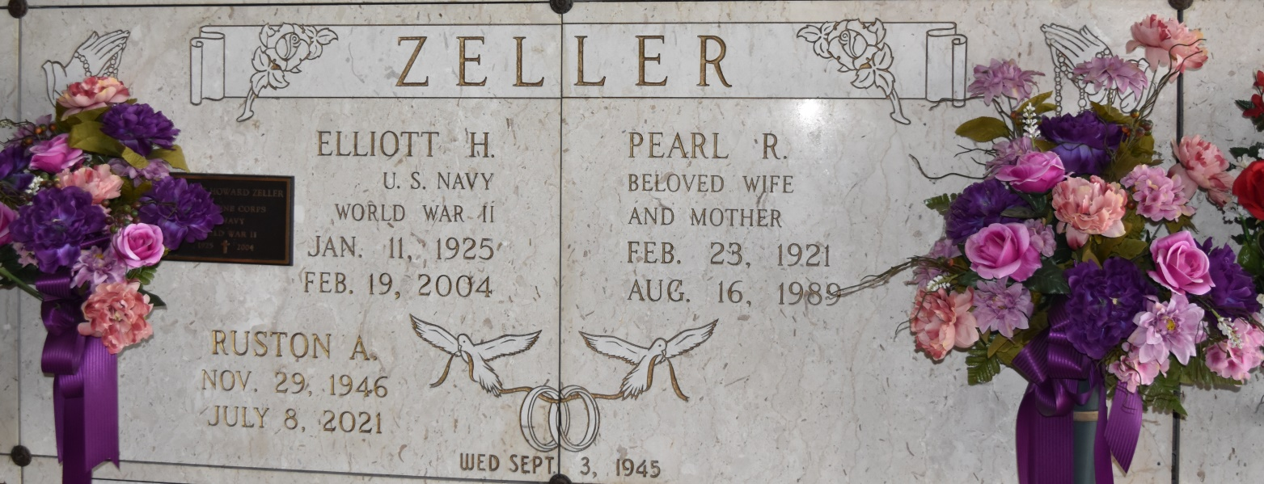

Ruston “Rusty” Anthony Zeller, a resident of Gonzales, passed away on July 8, 2021 at the age of 74.  Rusty loved all of his sons, daughter-in-laws, and his grandchildren.  He was Paw-Paw to all of the neighborhood kids.

Rusty is survived by his loving wife of 55 years, Terri Zeller; children, Fabian Zeller (Michelle), Tim Zeller (Wendy) and Glen Zeller; grandchildren, Hunter Zeller, Kali Zeller, and Brandon Zeller; sisters Cathy Marie Zeller Borne and Tammy Theresa Zeller Golladay (Tibbs); and sister-in-law, Debra Laurent Zeller.

He was preceded in death by his parents, Pearl Roussel Zeller and Elliott Howard Zeller; his sister, Judith Ann Zeller Garetino and her husband Joseph Garetino; his brother, Randy Bernard Zeller; and his brother-in-law, Billy Borne.

A visitation will be held at Rose Lynn Funeral Home on Saturday, July 10, 2021 from 10:00 AM to 12 Noon with a religious service at the funeral home beginning at noon.  Interment will be held at a later date.

Rose Lynn Funeral Home has been entrusted in handling his arrangements.

Rose Lynn Funeral Home, Lutcher, Louisiana