Damien John Powers
May 13, 1974 - July 18, 2024

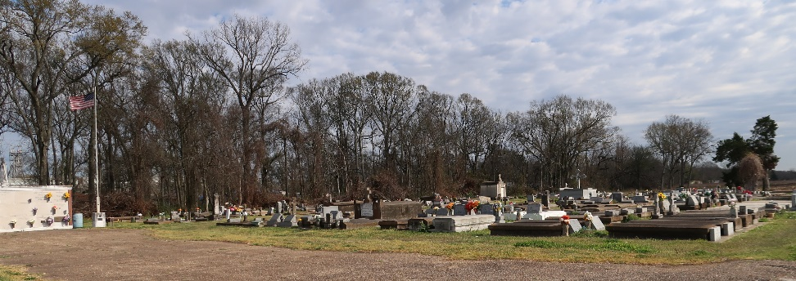

Damien John Powers passed away on Thursday, July 18, 2024 at the age of 50 after a three year battle with cancer.
Beloved fiancé of Erica Bordelon. Loving father of Khloe Powers and step-father of Joshua and Lucas LeBoeuf. Son of Adele Powers and the late James E. Powers. Brother of Kiley Powers (Rena). Uncle of Chase Powers. Also survived by family, friends and his faithful dogs Ozzie and Goose.
Damien’s family and friends meant the world to him. He was a lover of food, cars, music and life over all. He always had a smile on his face and never met a stranger. His heart was big and pure.

Relatives and friends are invited to attend the Visitation on Thursday, July 25, 2024 at St. Michael the Archangel Catholic Church, 6484 LA-44, Convent, LA from 9:00 a.m. to 11:00 a.m. followed by a Memorial Mass at 11:00 a.m. Interment in St. Mary Cemetery, Union, LA.

Rose Lynn Funeral Home, Lutcher, Louisiana
July 21, 2024

