Ruth (Louque) Accardo

January 14, 1924 - March 23, 2020

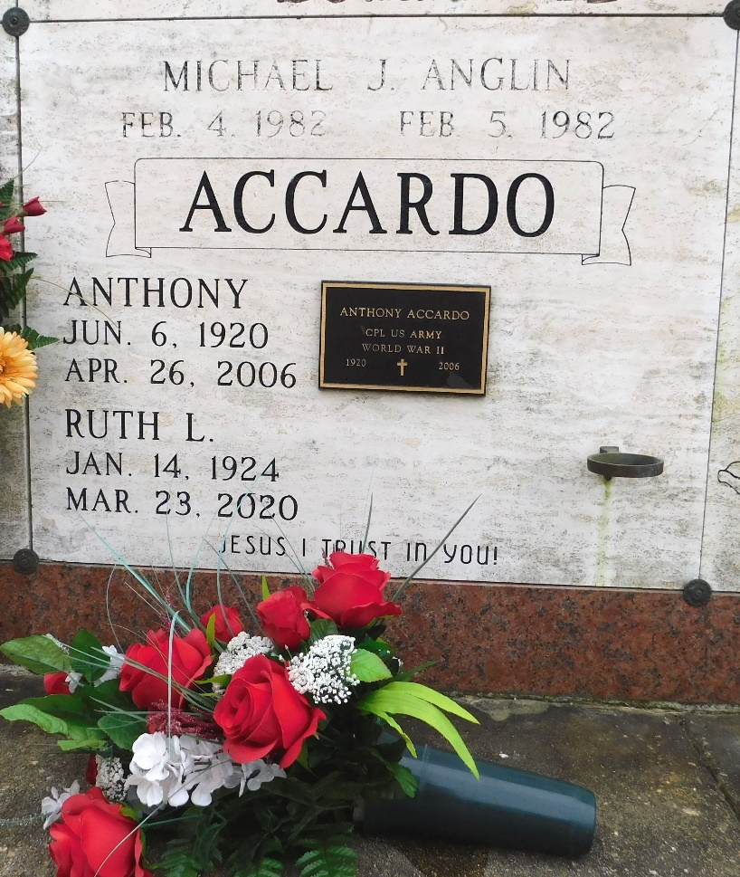

Photo by Mary Agnes Hammett

Ruth L. Accardo, a devout Catholic and loving mother and grandmother, passed away on Monday, March 23rd, 2020 at the age of 96. She was a resident of Hester, Louisiana.

She is survived by her children, Dale Accardo (Joycelyn), Ricky Accardo, Sr. (June), Donna A. Anglin (Don), Keith Accardo, Sr. (Darlene), Jody Accardo and Mary Accardo. Ruth is also survived by her grandchildren, Tony, Angela Martin, Ricky Jr. (Aleisha), Michael, Marcy Herrington (Lee), Keith, Jr. (Jenna), Dennis (Erin), Heather Wilson (Ricky) and Joshua as well as 14 great-grandchildren.

Ruth was preceded in death by her husband, Anthony Accardo; parents, Ulysse and Archange Bourgeois; daughter, Beverly Accardo; brothers, Manuel, Stark, Joseph and Ulysse, Jr. Louque; sisters, Lucia Louque, Merante Bourgeois, Marie Pizzuto, Louisiana Deslatte, Hilda Roussel, Florence Accardo and Alice Bourgeois.

Private services will be held for Ruth’s immediate family. The family would like to gratefully acknowledge Father Vincent Dufresne and Father Alec Sheldon for the prayers and blessings bestowed upon their beloved mother. They would also like to give special thanks to Dr. Vellinki and staff for their loving care.

Rose Lynn Funeral Home, Lutcher, Louisiana

March 24, 2020