Earl Joseph Fobb Sr.
November 8, 1950 - February 9, 2021

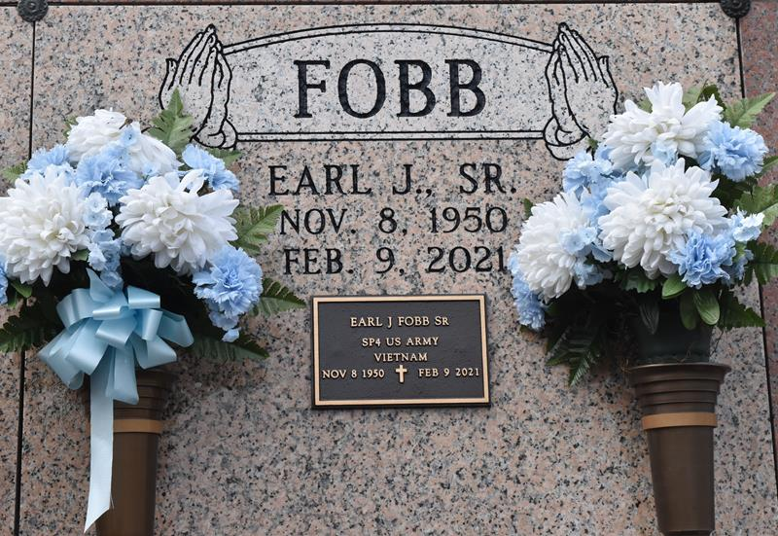

Earl J. Fobb Sr. of Gonzales, LA., departed this life on Tuesday, February 9, 2021 at The Crossing at Clarity Hospice in Baton Rouge, LA. He was 70 years.
Hambrick Family Mortuary, Gonzales, Louisiana
Feb. 12, 2021

