Carmel (Jacque) Gautreaux

June 20, 1931 - August 13, 2011

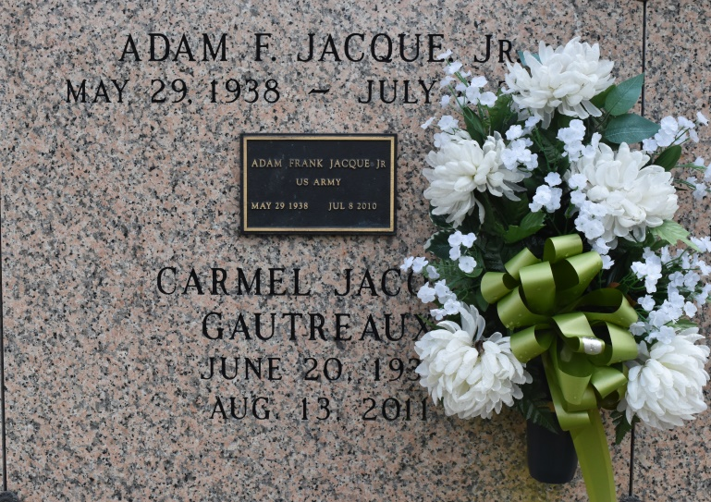

A native and resident of Convent, she died at River Parishes Hospital, LaPlace, at 11:45 p.m. Saturday, Aug. 13, 2011. She was 80. Visiting at St. Michael's Catholic Church, Convent, Thursday, Aug. 18, from 9 a.m. until Mass of Christian Burial at 11 a.m., with the Rev. Vincent Dufresne, celebrant. Entombment in church mausoleum.

Survived by her daughter, Inez Price Walker and husband Booker; son, Nathan Price and wife Pamela; stepson, Thomas Price Jr. and wife Thelma; sister, Diane Jacque; uncle, Frank Jacque Sr.; four grandchildren, three great-grandchildren, numerous sisters-in-law, brothers-in-law, nieces, nephews, cousins, other relatives and friends. Preceded in death by her parents, Adam Jacque Sr. and Odeal Braud Jacque; first husband, Thomas Price Sr.; second husband, Clifford Gautreaux; daughter, Debra Ann Price; and brother, Adam Jacque Jr. Arrangements by Brazier-Watson Funeral Home, Donaldsonville.

The Advocate, Baton Rouge, Louisiana

Aug. 17, 2011