Cyril Anthony Greene, Jr.

January 9, 1987 – March 10, 2019

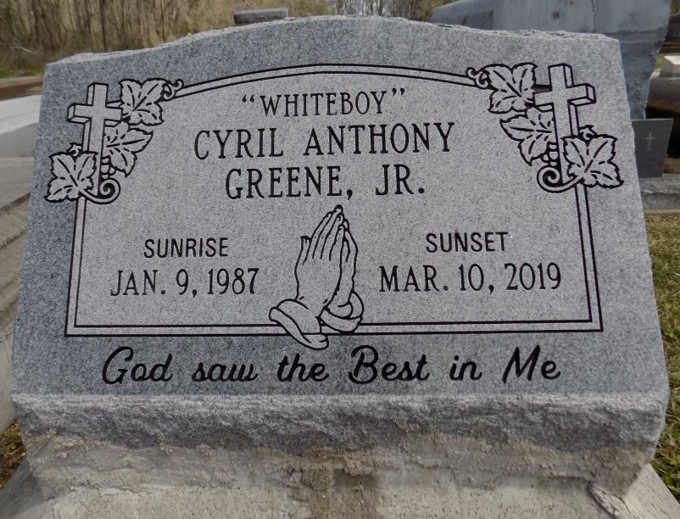

On Sunday March 10, 2019 Cyril A. Greene, Jr. passed away at the age of 32, Son of Peggy Cola and Cyril Greene Sr., father of Jace and Justen Green, and the late Cyril Greene III, Brother of Sheena Greene, Gwannette and Jamone Johnson. Uncle of Jaylon Edwards, Cyril is also survived by 4 step- sister, aunts, uncles, other relatives and friends.

Celebration service will be held on Thursday, March 21, 2019 at 11:00am at St. Michael Catholic Church 6476 La 44 Convent, LA. 70723. Deacon Alfred Adams officiating. Viewing from 9:00am until service time. Internment Church Cemetery. Professional Services entrusted to the caring staff Hobson Brown Funeral Home, 134 Daisy St., Garyville, La 70051. 985-535-2516.

The Advocate, Baton Rouge, Louisiana

Mar. 19 to Mar. 21, 2019.