Reverend Albert J. Hebert

1913 – April 5, 2003

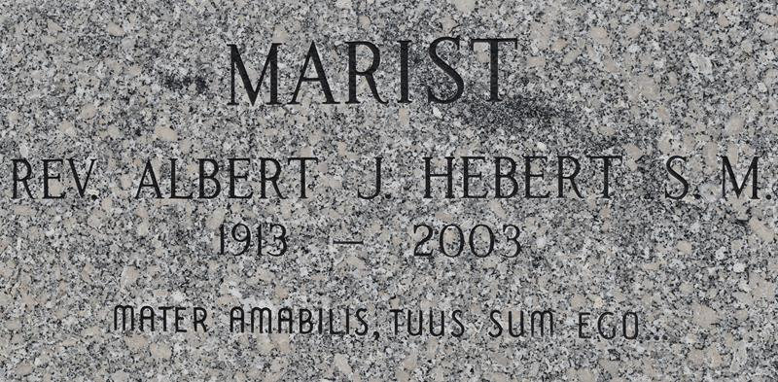

Father Albert J. Hebert, Jr., S.M., age 89, died on Thursday, April 5, 2003 in New Orleans, LA. Father Hebert was professed a Marist in 1948 and ordained to the Priesthood in 1954. He served in numerous Catholic parishes staffed by the Marists, most recently at St. Michael's Convent, LA and St. Jospeh's Paulina, LA. He was a resident at Our Lady of Wisdom Health Care Center. He served in the U.S. Army Air Corp during World War II. He is survived by two brothers, Charles J. Hebert and Paul J. Hebert; two sisters, Estelle Rouquette and Ruth Thomas as well as his confreres in the Marist Society.  
  
Visitation will be held at Holy Name of Mary Catholic Church, 500 Eliza Street, Algiers, LA on Tuesday, April 8, 2003 beginning at 4:30 PM with Wake Service at 6 PM. A Funeral Mass will be celebrated on Wednesday, April 9, 2003 fro 11 AM at the Church. Interment will follow at St. Michael's Convent, LA for 3 PM. In lieu of flowers, donations in memory of Fr. Hebert may be made to the Marist Community Support Fund, c/o Marist Center, 4408 8th Street, NE, Washington, DC 20017. Mothe Funeral Homes, Inc. in charge of arrangements. 366-4343.

Times-Picayune, The (New Orleans, LA) - Monday, April 7, 2003

Contributed by Jane Edson