Lawrence P. Jackson
March 9, 1939 – October 13, 2008

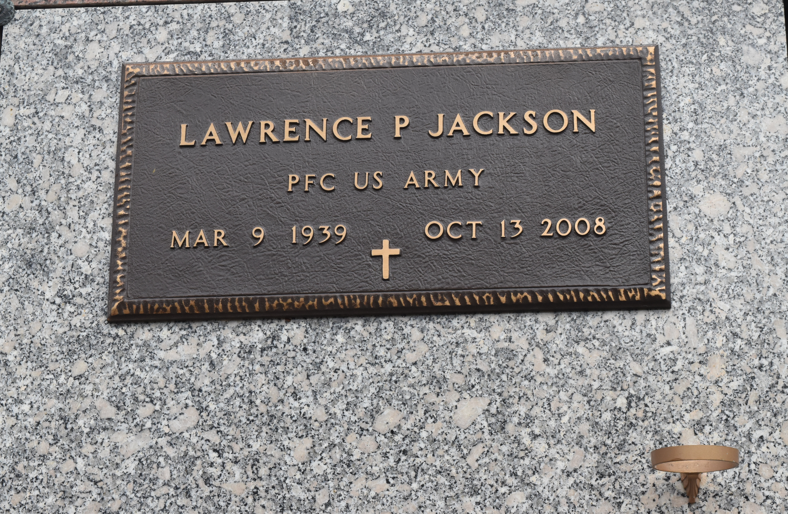

A maintenance supervisor with Dupont/Dow in Reserve, he died at 3:45 a.m. Monday, Oct. 13, 2008, at his residence in Gramercy. He was 69, a native of Convent and a U.S. Army veteran.

Visiting at St. Michael Catholic Church, Convent, on Friday, Oct. 17, from 9 a.m. to 10:50 a.m., and religious service at 11 a.m. Interment in church cemetery.

Survived by his wife, Earline Schexnayder Jackson; daughter, Ti Angela AlAmin; son, Marvin Jackson; two sisters, Marion Jackson and Brenda Chube; seven brothers, Milton, Claudell, Don, Leroy, Clifford, Nolan and Andrew Jackson; and stepchildren, Camille Zenon Jr., Susan Dumas and Rosalind Auzenne. Preceded in death by his parents, Victoria and James Jackson; first wife, Hilda Banks Jackson; and son, Dalton Jackson. He was a commissioner with the Port of South Louisiana. Arrangements by Baloney Funeral Home, LLC, Garyville.

Advocate, The (Baton Rouge, LA) - Thursday, October 16, 2008
Contributed by Jane Edson

