Adam Frank Jacque Jr.

May 29, 1938 – July 8, 2010

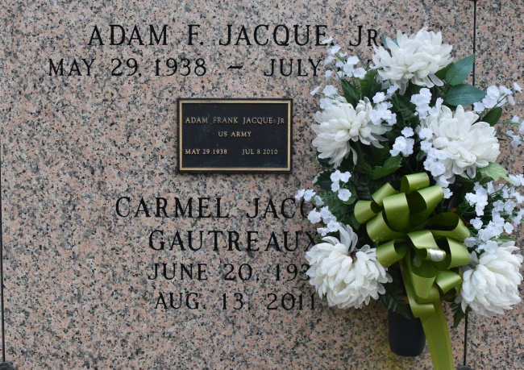

Adam Frank "Buggie" Jacque Jr. on Thursday, July 8, 2010 passed away at the age of 72. Beloved husband of Carolyn Sanders Jacque. A native of Convent, LA and resident of Kenner, LA. Father of Dwayne Jacque, Sr., Rachelle Defillo and the late Anton Jacque. Grandfather of 7 and great-grandfather of 4. Brother of Carmel Gautreaux and Diane Jacque. Brother-in-law of Sylvia McGlothen, Virginia LaBeaud, Clark, Phil and Larry Sanders. Survived by cousins, nieces and nephews.

Relatives and friends of the family, Employees of the City of N.O. Equipment Maintenance Division, Employees of Kenner Housing Authority, Jefferson Parish School System, Jefferson Retired Teachers Assoc., Associates and members of Primerica Financial Services, Japonicans, 4C's, also priests, parishioners, pastors, officers and members of Our Lady of Perpetual Help Church, St. Michael Church of Convent, LA, Providence Baptist Church of Kenner and all neighboring churches are invited to attend the Funeral Mass at Our Lady of Perpetual Help Catholic Church, 1908 Short St., Kenner, LA on Friday, July 16, 2010 at 12:00 noon. Father John Cisewski, celebrant. Visitation will begin at 10:00 a.m. to 12:00 noon. Interment: St. Michael Church Cemetery, Convent, LA. Richardson Funeral Home of Jefferson in charge of arrangements.

The Times-Picayune, New Orleans, Louisiana

Jul. 15 to Jul. 16, 2010.