Elaine Gloria (Simon) Johnson

October 22, 1940 – August 30, 2008

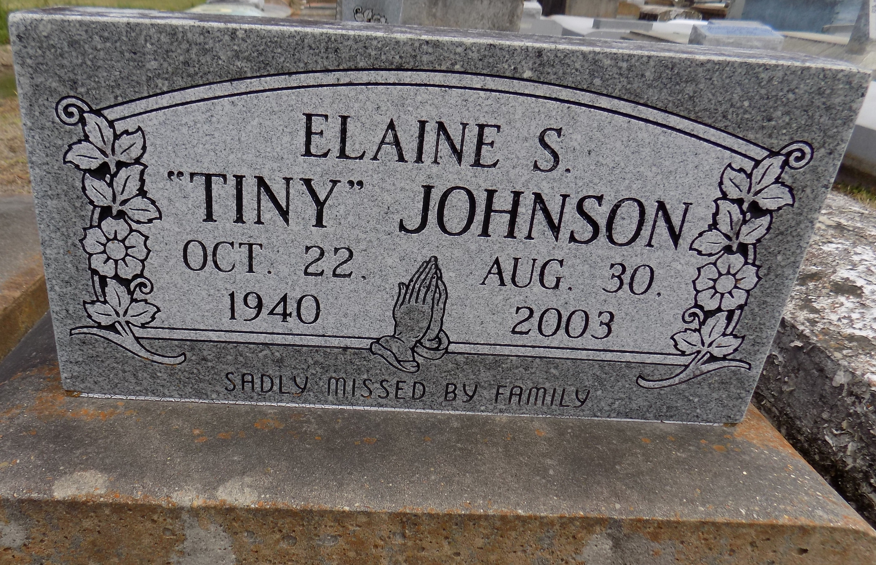

Elaine Gloria Johnson departed this life of Saturday, August 30, 2003 at Riverland Health Care Center Lutcher, LA. Daughter of the late Wilfred Sr. and Pauline (Clem) Simon. Wife of the late Richard Johnson, Sr. Mother of Richard Jr., Pauline Johnson and Stephanie (Aaron) Joshua. Sister of Sterling Simon of Reserve, LA, Gladys Shief of New Orleans, LA and Barbara Felton of Convent, LA. Also survived by 13 grandchildren, 6 sisters-in-law, 3 brothers-in-law, a host of nieces, nephews other relatives and friends. A native and resident of Convent, LA. Age 62 years.  
  
Relatives and friends of the family, also priest and parishioners, St. Michael Catholic Church and all neighboring churches are invited to attend the Mass of Christian Burial of Friday, September 5, 2003 at 11:00 AM at the above named Church, Hwy 44, Convent, LA. Father Ed Fuss Celebrant. Interment in Church Cemetery, Convent, LA. Viewing will be on Thursday 5:00 PM until 7:00 PM at the Funeral Home, 134 Daisy St. and on Friday 9:00 AM until service time. Rosary at 10:15 AM. Interment in St. Michael Cemetery, Convent, LA.  
  
Services Entrusted to Hobson Brown Funeral Home.

Times-Picayune, The (New Orleans, LA) - Thursday, September 4, 2003

Contributed by Jane Edson