Robert Mark Jones
March 1, 1952 – June 25, 2010

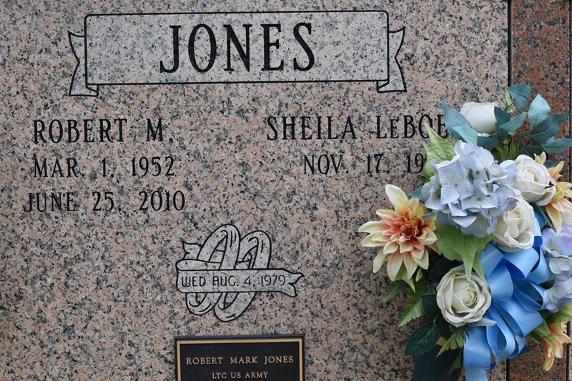

Robert Mark "Bobby" Jones died as a result of an automobile accident on Friday, June 25, 2010 at 3:15 P.M., at St. James Parish Hospital, Lutcher, LA.
Son of Joseph Jones, Sr. and the late Rita Jones Jones. Beloved husband of Shelia LeBoeuf Jones. Father of Ashley, Jared and Christopher Jones. Brother and brother in law of Nadine and Earl Taylor, Naomi and Cheryl Jones, Joseph and Leonarda and Lester Jones. Son in law of Geraldine Jacque LeBeouf and the late Joseph LeBeouf, Sr. Brother in law of Joycelyn and Kenneth Steib, Donna and Heria Williams, Glenda and Matthew Randle, Faye and Johnny Bradley, Genell and Juan Patterson, and Sharon and Wayne LeBeouf. Nephew of Howard Jones, Thelma and Armand Augustus, Stella Mae Jones and Alvin Piper. Godfather of Coye Scott and Duane Jackson. Also survived by numerous nieces, nephews, cousins, other relatives and friends. Age 58.
Relatives and friends of the family, also members of the Knights of Peter Claver, 3rd and 4th Degree Order, are invited to attend the Mass of Christian Burial at St. Michael's Catholic Church, Hwy. 44, Convent, LA, Thursday, July 1, 2010 at 11:00 A.M. with viewing beginning at 9:00 A.M. Conducted by the Rev. Vincent Dufrene and Deacon Alfred Adams. Recitation of the Rosary at 10:00 A.M., followed by burial rites by the Knights of Peter Claver, 3rd & 4th Degree Order. Entombment in St. Michael's Mausoleum, Convent, LA. Brazier-Watson Funeral Home in charge of arrangements.

The Times-Picayune, New Orleans, Louisiana
Jun. 30, 2010

