Mary Ann (Granier) Lambert
March 8, 1946 - April 4, 2020

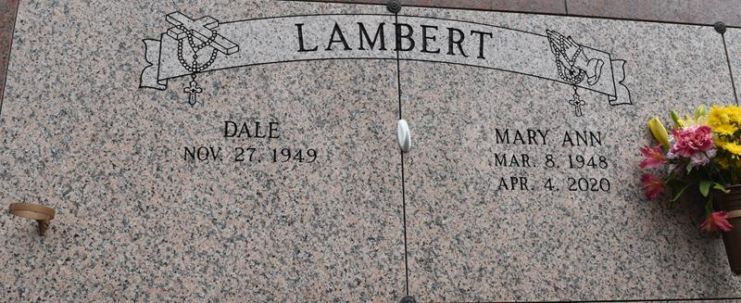

Mary Ann Granier Lambert, a resident of Lutcher, LA, passed away on Saturday, April 4, 2020 at St. James Parish Hospital at the age of 72. She was born on March 8, 1948 in St. James, LA to the late Louis and Edna Chiquet Granier.
She is survived by her husband Dale Lambert, Sr; daughter, Trude Lambert Montz (Chris Montz, Jr); grandchildren, Kassie and Kohen; brothers, Thomas Granier (Lilly), Timothy Granier (Louise) and Robert Granier; and numerous nieces and nephews.
She was preceded in death by her son Dale Lambert, Jr.; and brothers, Earl, Eugene, Raymond and Larry Granier.
She was admired for the endless care she gave her son who was disabled with muscular dystrophy. She was devoted to her Catholic faith. The love given to her family and friends was in abundance.
The family would like to thank Dr. Vellanki, Dr. Roussel, Holly Millet, Staff of St. James Parish Hospital and the staff of Chateau St. James Retirement Home for their excellent care and compassion. No words can describe our heartfelt appreciation to all during this difficult time.
Due to the current circumstances, a private service will be held for immediate family only at St. Michael’s Cemetery.
In lieu of flowers any donations can be made to the Muscular Dystrophy Association.

Rose Lynn Funeral Home, Lutcher, Louisiana
April 6, 2020

