Charles Joseph Landry, Sr.
November 5, 1930 – August 18, 2017

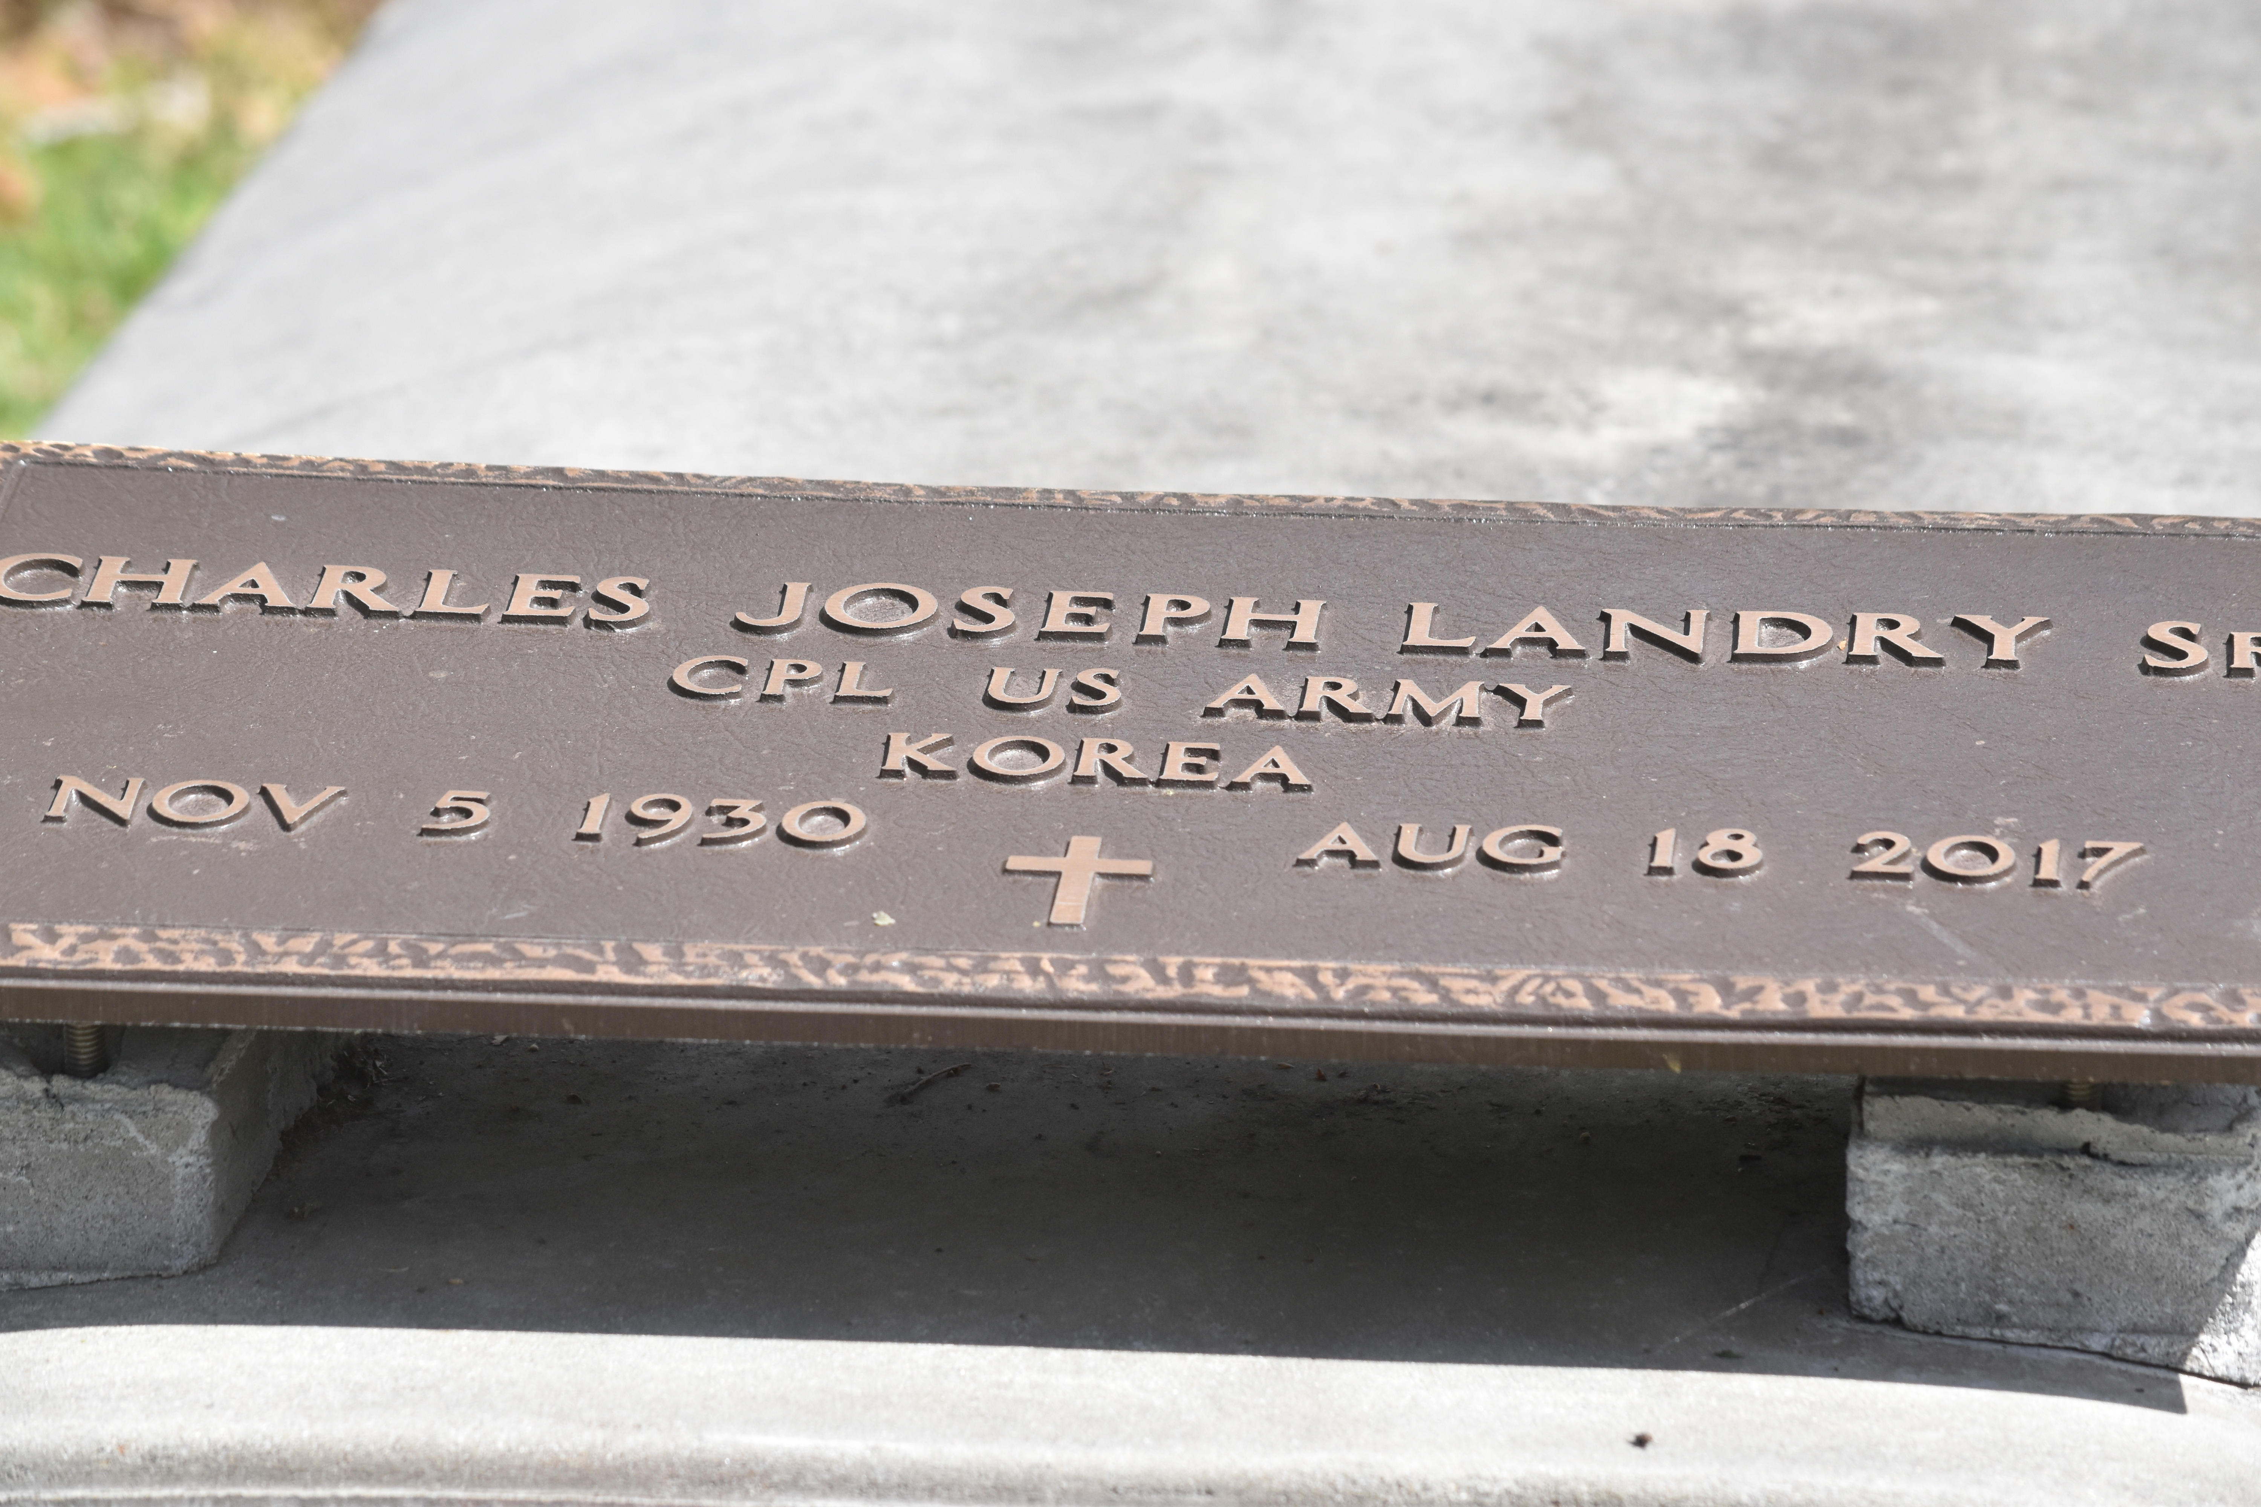

Charles "Charlie" Landry Sr. at the age of 86yrs. departed this earthly life on Friday August 18,2017 at Our Lady of The Lake Hospital of Baton Rouge, La. Beloved Husband of Ernestine Johnson Landry of Convent, La. Loving Father of Charles Landry Jr. (Lynn), Iris Jackson, Lester Landry (Carolyn), Elvis Landry and Deena LeBlanc (Quentin). Brother of Genevieve Roberts. Also survived by 14 grandchildren, great-grandchildren, nieces, nephews other relatives and friends. Charles was a long time resident of Convent, La.

He was preceded in death by his parents: Pauline Landry and George Landry Sr.; Siblings: George Landry Jr., Ethel Johnson and Margaret Steptore.

Priest and parishioners of St. Michael's Catholic Church of Convent, La. and all neighboring churches are invited to attend a mass of Christian burial on Saturday August 26, 2017 at 10:00am at St. Michael Catholic Church 6476 Hwy.44 Convent, La. Father Alec Sheldon, Celebrant. Interment in St. Michael Cemetery. Visitation will be at the above name church from 8:00am until service time. Bardell's Mortuary of Mt. Airy, La. in charge. Information: 985-535-6837.

Advocate, The (Baton Rouge, LA) - Thursday, August 24, 2017
Contributed by Jane Edson

