Clarence Nicholas Sr.
January 10, 1908 – April 18, 2001

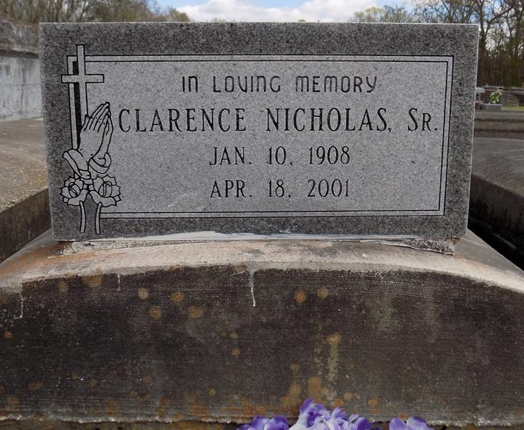

A native and resident of Convent, he died Wednesday, April 18, 2001. He was 93. Visiting at Pleasant Hill Baptist Church from 9 a.m. Saturday until religious services at 11 a.m., conducted by the Rev. Virgil Scott. Interment in St. Micheal Cemetery. Survived by his wife, Louise Nicholas; six daughters, Lillian Nicholas, Angella Williams, Doris Nicholas, Vivian Felton, Gladys Vancourt and Ella Mae Nailor; two sons, Clarence Nicholas Jr. and Hilton Nicholas; 30 grandchildren; and 45 great-grandchildren. Preceded in death by his parents, Virginia and Edmond Nicholas; two daughters, Virginia Nicholas and Augustine Lawson; a sister, Lou Ella Mitchell; and a brother, Fredrick Nicholas. Baloney Funeral Home, Garyville, in charge of arrangements.
Advocate, The (Baton Rouge, LA) - Friday, April 20, 2001
**
CONVENT – Clarence Nicholas Sr., 93, a native and resident of Convent, died April 18. He was the husband of Louise Nicholas and father of Angella Williams, Vivian Felton, Gladys Vancourt, Ella Mae Nailor, Louise, Lillian, Doris, Clarence Jr. and Hilton Nicholas. He was also the son of the late Edmond and Virginia Nicholas and brother of Lou Ella Mitchell and Fredrick Nicholas. He is also survived by 30 grandchildren and 45 great-grandchildren. Services are today at 11 a.m. at Pleasant Hill Baptist Church, Convent, with interment at St. Michael Cemetery, Convent. Visitation starts at 9 a.m.

L’Observateur, LaPlace, Louisiana; Saturday, April 21, 2001

