Anthony Gayle Poche, M.D.
April 17, 1931 – April 27, 2000

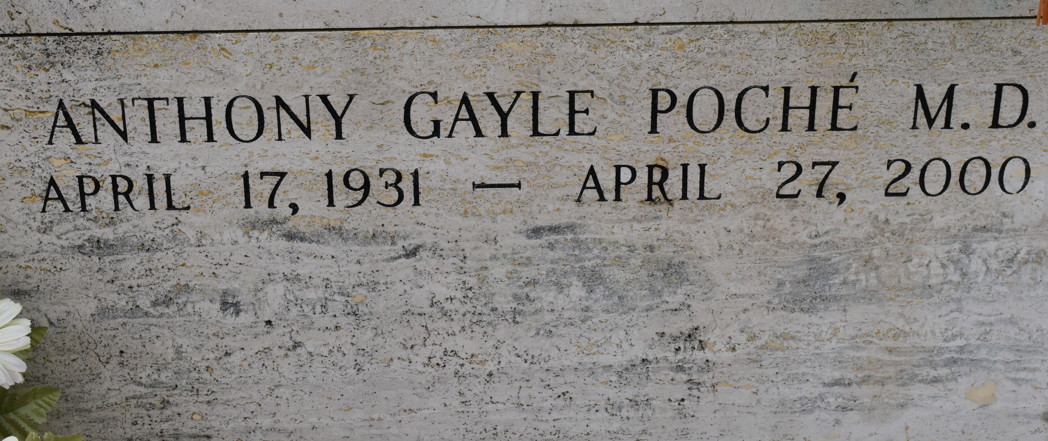

Dr. Anthony Gayle Poche, a retired anesthesiologist, died Thursday of cancer at his home. He was 69. Dr. Poche was born in Convent and lived in Metairie for many years. He graduated from Louisiana State University and its School of Medicine and the University of California, San Francisco. He practiced medicine in Raceland, Gramercy and in New Orleans at Southern Baptist Hospital, now Memorial Medical Center. He was president of the hospital's medical executive committee in 1981 and president of its medical staff. Mr. Poche was a member of Alpha Omega Alpha and Omicron Delta Kappa and a diplomat in the American Board of Anesthesiologists. He was an Army veteran.

Survivors include his wife, Bessie Troxclair Poche; two daughters, Claire P. Chachere and Adele P. Eisenbraun; seven brothers, the Rev. Louis A. Poche, S.J., of Gramercy, Joseph R. Poche of Lutcher, Leon K. Poche of Crowley, James C. Poche of New Orleans, Neal T. Poche of Hester, Francis Jay Poche of The Woodlands, Texas, and John B. Poche of Shreveport; and two grandchildren.

A Mass will be said today at 11 a.m. at Sacred Heart of Jesus Catholic Church in Gramercy. Visitation will begin at 9 a.m. Burial will be in St. Michael Mausoleum in Gramercy. Leitz-Eagan Funeral Home is in charge of arrangements.

Times-Picayune, The (New Orleans, LA) - Saturday, April 29, 2000
Contributed by Jane Edson

