Clifford Charles Roberts, Sr.
December 8, 1919 – February 25, 2009

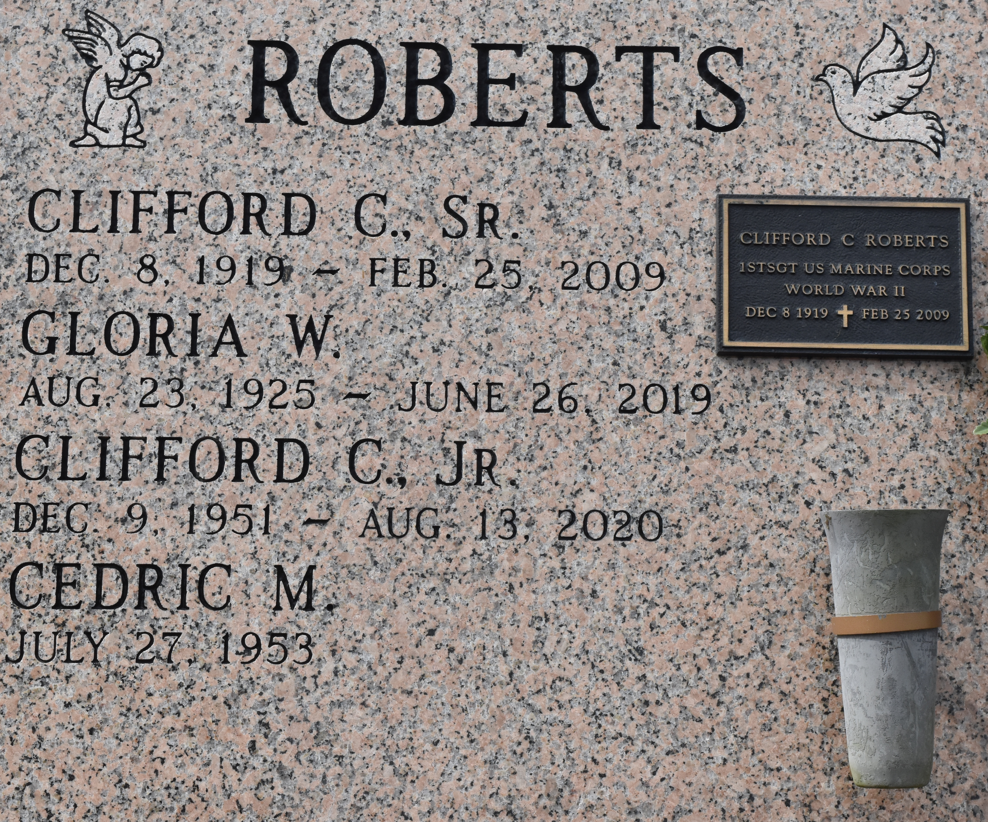

A native and resident of Convent, he passed away at his daughter’s home in San Diego at 9:30 p.m. Wednesday, Feb. 25, 2009. He was 89.
Visiting at St. Michael’s Catholic Church, Convent, on Saturday, march 14, from 10 a.m. until Mass of Christina Burial at 11 a.m. with the Rev. Jason Palermo, celebrant, and Deacon Alfred Adams. Inurnment in the church mausoleum.
Survived by his wife, Gloria Weaver Roberts; daughter and son-in-law, Alanna and Ram Lal; two sons, Cedrick Sr. and Clifford C. Roberts Jr.; grandchildren, Cedrick Roberts, Jr., Daniel and Noel Roberts; and former daughter-in-law, Judy Madison Roberts. He was the stepgrandfather of Keith Lal, and Christopher and wife Amy Lal; and brother-in-law of Gevieve Roberts and Gilbert and Margie Weaver. He is also survived by nieces, nephews, cousins, other relatives and friends.
Preceded in death by his parents Louis Sr. and Louise Abadie Roberts; four sisters, Eva Gauthreaux, Consuella and Marie Roberts and Alice Roberts Green; six borhters, Louis Jr., Horace, Isaac, Leon, Roy and John Roberts; Father-in-law and mother-in-law, William R. Weaver and Edna Weber Weaver Winston.
Arrangements by Brazier-Watson Funeral Home of Donaldsonville.

The Advocate, Baton Rouge, Louisiana; Friday, March 13, 2009, p. 13
Contributed by Jane Edson

