Marguerite Rose (Louque) Roussel
August 30, 1922 – August 30, 2022

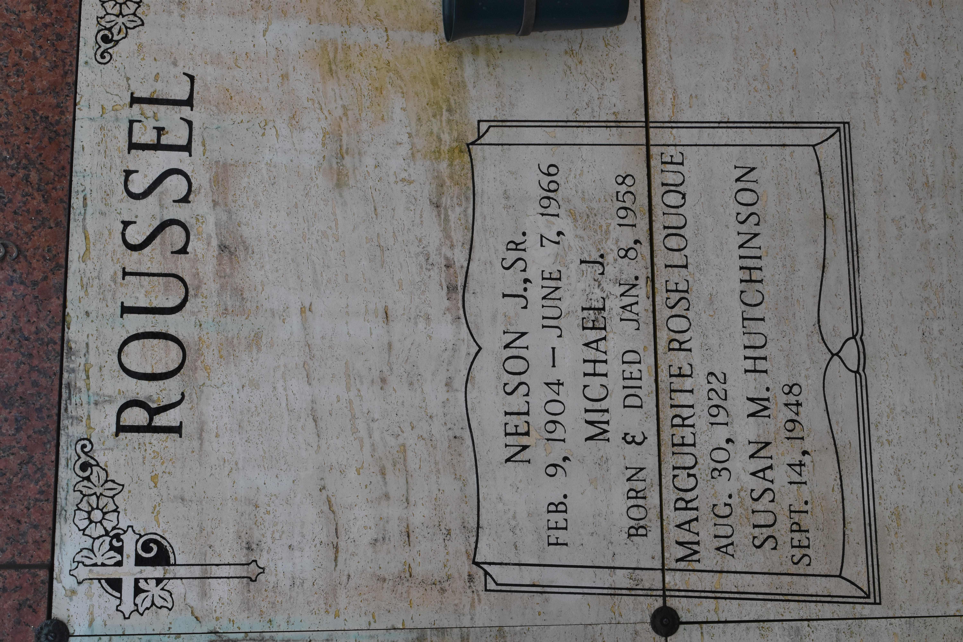

Marguerite “Git” Louque Roussel, a lifelong resident of Hester, Louisiana, was born on August 30, 1922, and passed away on her 100th birthday, August 30, 2022.
She is survived by her children, Sharon Roussel Kliebert, Shirley Roussel Haase, Nelson Roussel, Jr. (Myrleen), Susan Roussel Hutchinson (Douglas), Leonard Roussel (Cindy), and Tammy Roussel Woods (Alvyn); 13 grandchildren, Michelle Bourgeois Weber (O’Neal), Jon Bourgeois (Heidi), Ray Kliebert, Jr. (Amy), Hollie Kliebert Haydel (Tray), Jude Haase (Holly), Lauren Haase (Jared), Joseph Roussel, III (Stephanie), Todd Roussel (Paula), Jennifer Roussel Milazzo (Kyle), Chad Roussel (Direxa), Jamie Roussel Luquette (Keith), Stacey Roussel (Troy), and Anna Woods; 27 great-grandchildren, Ashton & O’Neal Weber, Caleb & Caitlyn Bourgeois, Grace, Ray III, & Riley Kliebert, Tayden & Brantley Haydel, Alyssa, Cole, & Cason Haase, Brock, Rory, & Ramsey St. Amant, Devin Roussel (Jolie), Hannah & Brooke Roussel, Marshall, Alex, & Samuel Milazzo, and Parker, Cam, Kadynn, Carson, Carter, & Cooper Roussel; sisters, Melodie “Mickey” Ory and Elizabeth “Betty” Scott; brother-in-law, Jean Troxclair; and sisters-in-law, Janet Louque and Ann Louque.
Marguerite was preceded in death by her husband Nelson Joseph Roussel, Sr.; children, infant Michael Roussel and Evela Roussel Bourgeois (Maurice); sons-in-law, Ray Kliebert, Sr. and Jerry Haase; grandchildren, infants Joseph and Michelle Bourgeois; parents, Alfred and Melodia Louque; siblings, Whitley “Whit” Louque (Wandene), Ferdinand “Knox” Louque (Helen), Hubert “Karot” Louque (Virginia), Hilton “Buck” Louque (Shirley), Raymond “Pieyas” Louque (Dorothy), Alfred “Peck” Louque (Katherine), Louisa “Gal” Troxclair, Melvin “Cacoon” Louque, Robert “Bobby” Louque, Eula Mae “Mitsy” Louque, and Joyce Olivier (Marc, Jr.); and brothers-in-law, Royal Ory and George Scott.
A member of Catholic Daughters, Git was kindhearted with a gentle soul and loved visits from her family. She took pride in caring for her colorful varieties of day lilies and azaleas. A lover of outdoors, Git enjoyed bird watching from her porch rocking chair amongst the oaks. Marguerite was meticulous and took pride in her home. She particularly loved decorating for the holidays, especially Christmas. Music runs deeply in her family, and she would light up listening to her loved ones playing guitar and singing.
The family would like to thank the staffs of Our Lady of the Lake Hospital and Pinnacle Hospice for their special care and compassion given to Marguerite.
Relatives and friends are invited to attend services. A visitation in Git’s honor will be held on Saturday, September 3, 2022 from 8:30 to 10:00 am at St. Michael the Archangel Catholic Church in Convent, LA with a Mass of Christian Burial at 10:00 am. Burial will follow in the St. Michael Cemetery.
Rose Lynn Funeral Home is in charge of arrangements. To view or sign the online guestbook, please visit roselynnfuneralhome.com.
Rose Lynn Funeral Home, Lutcher, Louisiana

