F. Gottfried Schiffers

September 21, 1914 – March 9, 2009

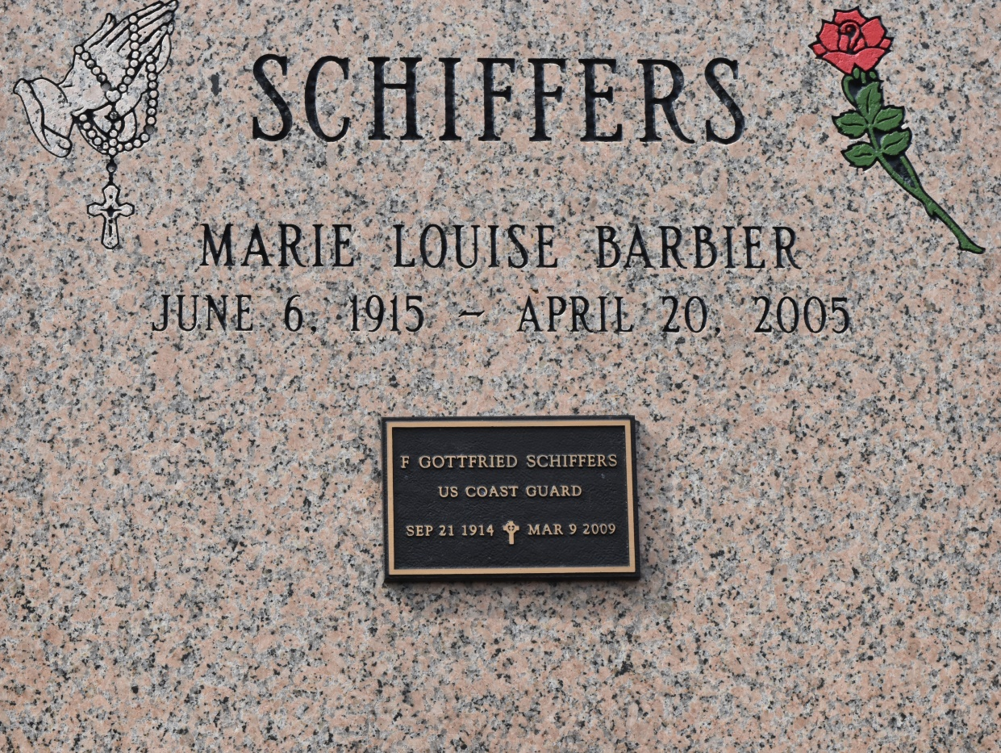

Gottfried Schiffers, 94, of Lacombe, LA, passed away on Saturday, May 9, 2009. Beloved husband of the late Louise Barbier Schiffers. Father of Kenneth Schiffers (Lynn) and Ronald Schiffers. Son of the late Gottfried and Cecelia Schiffers. Brother of Liliane S. Atwood of Penny Farms, FL. Also survived by two grandchildren: Stacey and Diamond Schiffers; and one great-grandchild: Violettte Schiffers.

A native of Brooklyn, New York, Mr. Schiffers was retired from the U.S. Coast Guard, after 26 years of service, (1936-1962) including his service during World War II, as well as Lighthouse Keeper from 1960 to 1962 of the Boston Light (America's first lighthouse), in Boston, MA, and also retired from the Louisiana Dept of Hwys. His hobbies included playing the guitar, banjo, mandolin, and writing songs.

A Graveside service will be held on Wednesday, May 13, 2009, at St. Michael the Archangel Catholic Cemetery, 6484 LA 44, in Convent, LA at 10:30am. Arrangements by Honaker Funeral Home, Inc., Slidell, LA.

The Times-Picayune, New Orleans, Louisiana

May 12, 2009