Della (Braud) Starlone

October 17, 1946 – June 7, 2002

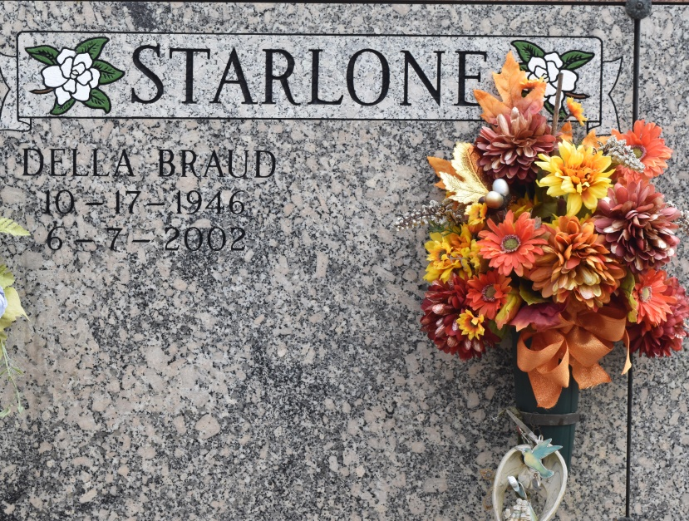

Della B. Starlone, a loving and devoted wife, mother and grandmother, died on Friday, June 7, 2002 at Our Lady of the Lake Hospital in Baton Rouge. Beloved wife of Anthony Starlone. Mother and mother-in-law of Jason and Rachel Starlone and Bart Starlone. Grandmother of Taylor Starlone. Daughter of Enola C. Braud and the late Olidie Braud. Sister of Dennis Braud, Ralph Braud, Glenn Braud, Mark Braud, Gayle Plaisance and Janice Bourg. Daughter in law of Mary Starlone and the late Steve Starlone. Sister-in-law of Lillian Starlone and Nick Starlone. Age 55 years. A native of Chackbay and a resident of Hester, Louisiana.

Relatives and friends of the family are invited to attend the Funeral Services. A Mass of Christian Burial will be celebrated by the Reverend Mario Rizzuto at St. Michael Catholic Church on Monday, June 10, 2002 at 10:00 A.M. Friends may call at H.C. ALEXANDER FUNERAL HOME OF LUTCHER, 2208 Jefferson Highway, on Sunday evening from 6:00 p.m. until 10:00 p.m. and on Monday morning from 7:00 a.m. until 9:00 a.m. Entombment following at St. Michaels Mausoleum.

The Times-Picayune, New Orleans, Louisiana

Jun. 8, 2002