Mary (Garaci) Starlone
December 6, 1904 – May 17, 2003

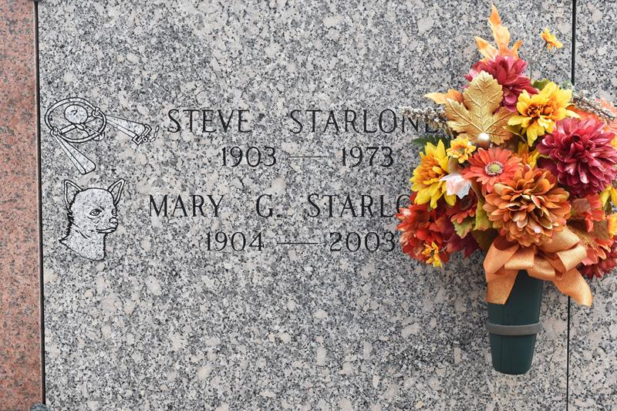

Mary Garaci Starlone, born December 6, 1904, died Saturday, May 17, 2003 at 6:30AM. Age 98 years. A native of Franklin, LA and a resident of Hester, LA.
Survived by 2 sons, Nick and Anthony Starlone. Sister Alice Cambre., also survived by 4 grandchildren and 6 great grandchildren. Preceded in death by her husband Steve Starlone and parents, Antonio and Maria Santa Coletta Lanza Garaci.
Visitation Sunday, May 18, 2003 from 6PM until 9PM and on Monday, May 19, 2003 at 8AM until funeral time at Rose Lynn Funeral Service in Lutcher, LA. Mass of Christian Burial on Monday, May 19, 2003 at 11AM at St. Michael Church in Convent, LA. Interment in St. Michael Cemetery in Convent, LA. Rose Lynn Funeral Home in charge of arrangement
The Times-Picayune, New Orleans, Louisiana
May 18, 2003

