Melba (Banks) Taylor

November 14, 1950 – March 19, 2007

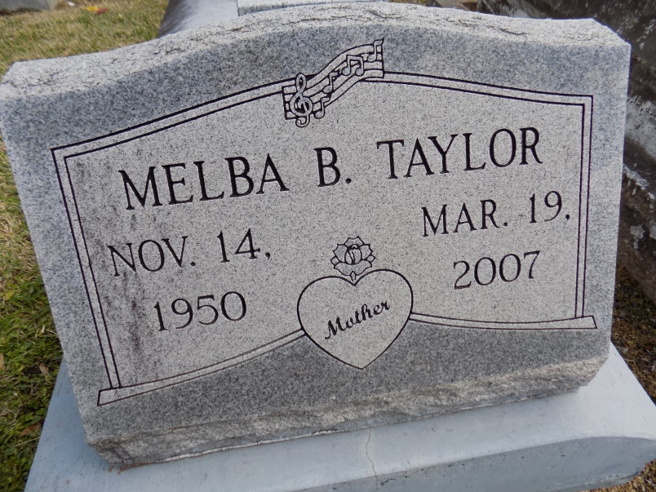

Taylor, Melba Banks - A native and resident of Convent, she died Monday, March 19, 2007, at Our Lady of the Lake Regional Medical Center. She was 56. Visiting at St. Mary's Catholic Church, Convent, on Thursday from 8:30 a.m. until Mass of Christian Burial at 10:30 a.m., conducted by the Rev. Pat Mascarella, celebrant, and Deacon Alfred Adams. Burial in St. Michael's Cemetery in Convent.

She is survived by two daughters and sons-in-law, Tina Taylor Jones and Troy and Danita Taylor Morris and Merlin; son, Lloyd Taylor Jr. and his companion, Sharell; three sisters and two brothers-in-law, Betty Hayes, Laverne and Joseph McKinley and Geraldine Dunn and Andrew; three brothers and a sister-in-law, Melvin Banks and Elouise, and Lloyd and Richard Banks; her companion, Donald Ray James; seven grandchildren, numerous aunts, uncles, nieces, nephews, cousins, godchildren, other relatives and friends. She was preceded in death by her parents, Matthew Banks and Melba Jones Banks; and brother-in-law, Irvin Hayes.

Arrangements by Brazier-Watson Funeral Home, Donaldsonville.

The Advocate, Baton Rouge, Louisiana

Mar. 21, 2007