Herman Joseph Vancourt, Sr.

April 30, 1914 – January 12, 2002

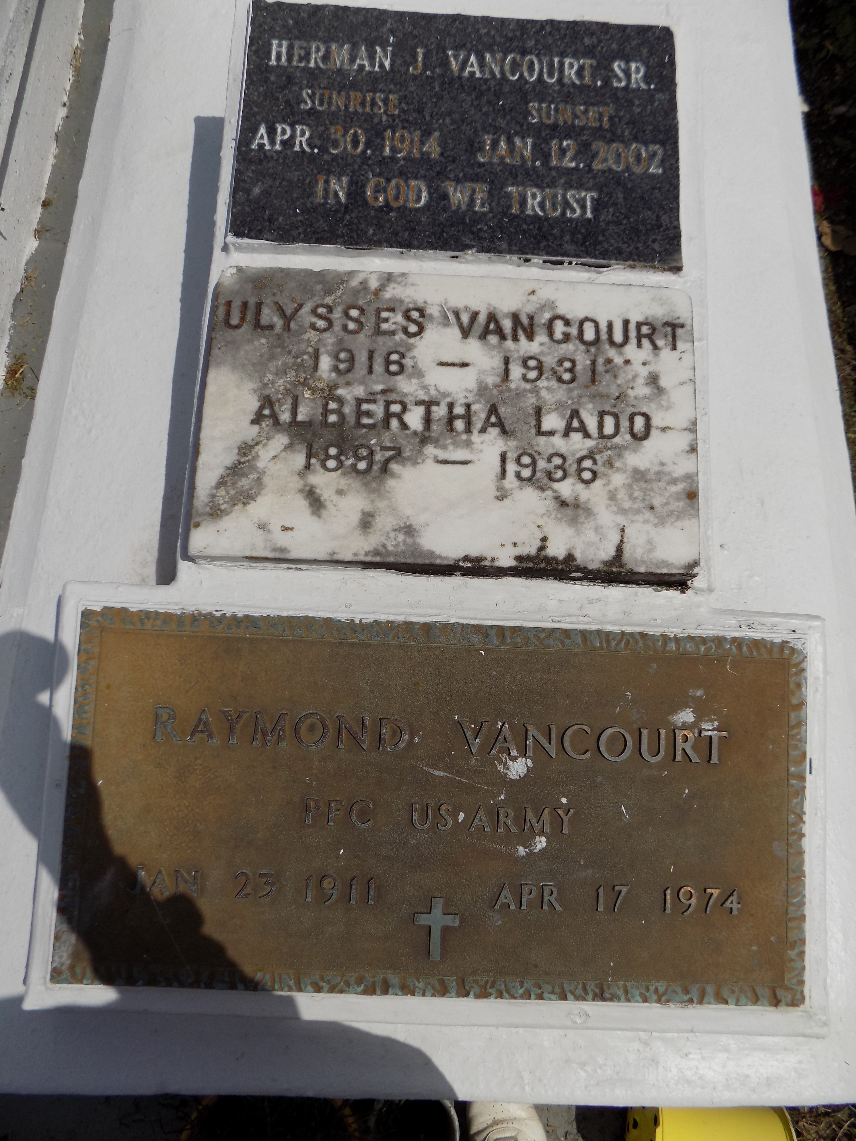

ALGIERS - Herman Joseph Vancourt Sr., 87, a native of Convent and resident of Gretna, died Jan. 12. He was the husband of Florestine Celestin Vancourt and father of Glinda Williams, Althea Druhet and Herman and Ulysses Vancourt.  
  
He is also survived by eight grandchildren and five great-grandchildren.  
  
Services are today at 10 a.m. at All Saints Catholic Church, Algiers, with interment at St. Michael Cemetery, Convent. Visitation starts at 8 a.m.

L'Observateur (La Place, LA) - Thursday, January 17, 2002

Contributed by Jane Edson