Emelda J. West

August 22, 1925 – March 30, 2013

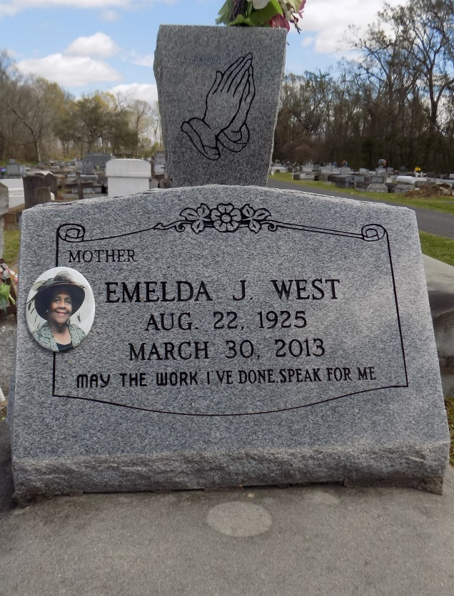

Emelda West went home to be the lord on Saturday March 30, 2013. Mother of Charmaine West Carter- Wright, Harrison, Glenn, Sebastian and Terrance West, sister of Ethel Reid Smith and Mable Walker also survived by a host of other relatives and friends.

Services will be held on Wednesday April 03, 2013 at 12:00 noon at Pilgrim full gospel church 10118 Legion St. Convent, La, Rev. Marshall Cooper Sr, officiating. Internment in St. Michael Catholic Cemetery Paulina, La, Viewing from 10am until service time. Services entrusted to Hobson Brown Funeral Home, 134 Daisy St. Garyville, La 70051, (985) 535-2516.

The Advocate, Baton Rouge, Louisiana

Apr. 2 to Apr. 3, 2013