Kevin P. West

September 12, 1952 – August 30, 2005

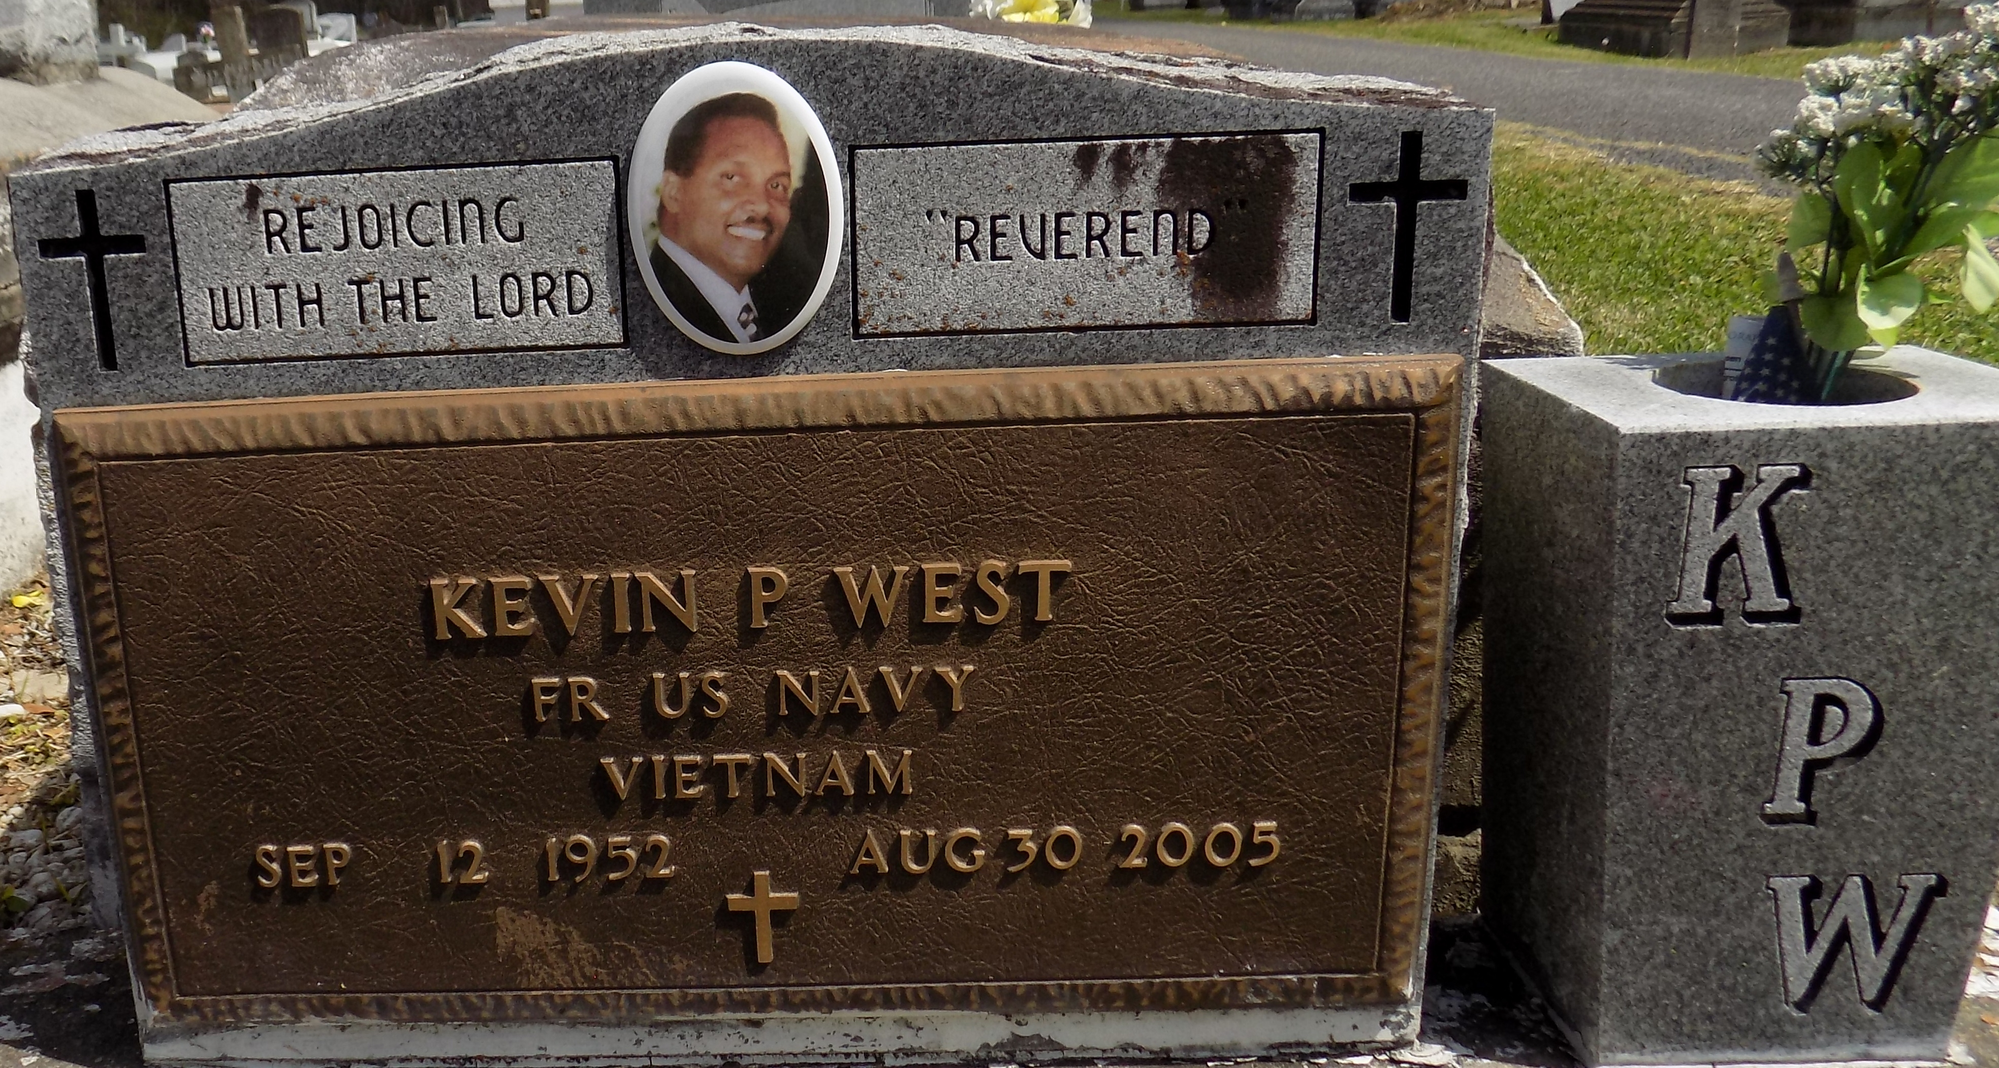

The Rev. Kevin Paul West Sr., known to many as Paul, went home with the Lord on Tuesday, Aug. 30, 2005. He was the son of Emelda J. West and the late Melvin West. He was the husband of Sheila West and the father of son, Kevin Jr., and daughters, Nicole and Crystal, all of San Jose, Calif. He was the brother of Harrison, Glenn, Sebastian, Terrence and Charmaine, and the grandfather of four grandchildren. He was preceded in death by his sister, Yolanda Ann West.

Lawson-Rollins Purple Shield Funeral Home, Gonzales, is in charge of arrangements.

Advocate, The (Baton Rouge, LA) - Wednesday, September 7, 2005

Contributed by Jane Edson