Christopher L. White
July 8, 1982 – June 29, 2000

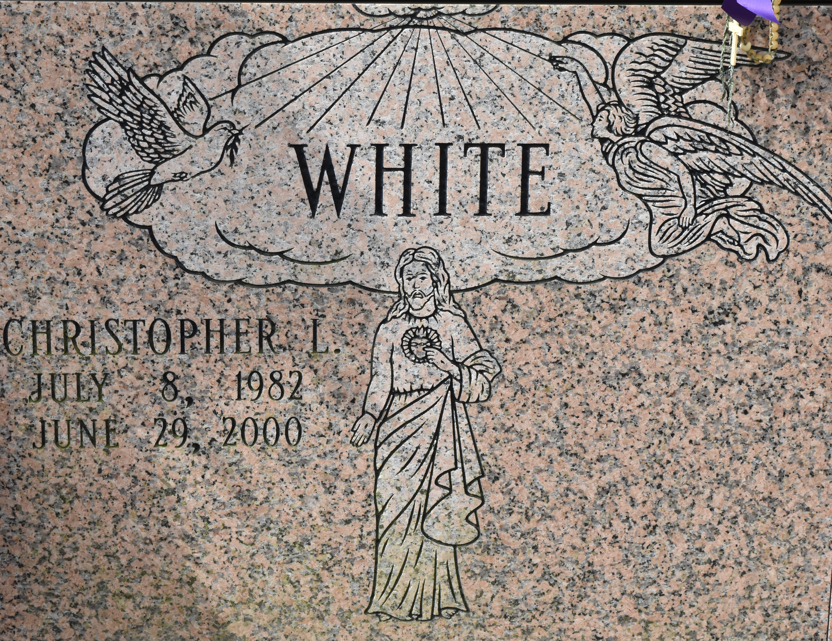

Christopher White: 17-year-old dies after car crashes
17-year-old dies after car crashes
A Convent teen-ager was killed Thursday afternoon when he ran his car off La. 44 in St. James Parish and hit a tree and fence, State Police Troop A said Friday. Christopher White, 17, was ejected from his 1989 Oldsmobile, troopers said. State Police did not have White's address Friday. The crash occurred at 3:50 p.m. on La. 44 one mile south of La. 70. Troopers said White was driving north on La. 44 when he tried to pass a car in front of him, lost control of his vehicle for an unknown reason and ran off the road.
Advocate, The (Baton Rouge, LA) - Saturday, July 1, 2000
*****
Christopher Lee White, 17

A student at St. Amant High School and a resident of Convent, he died at 3:30 p.m. Thursday, June 29, 2000, on La. 44, Convent. He was 17. Visiting at Jeremiah Baptist Church, Donaldsonville, from 10 a.m. until religious services at 11 a.m. Monday, conducted by the Rev. Joseph White. Interment in St. Micheal Cemetery, Convent. Survived by his parents, Lee Arthur and Nancy White, Convent; a brother, Eugene White, Convent; and uncles, aunts, other relatives and friends. Preceded in death by his grandparents; three uncles; an aunt; and a cousin. Lawson-Rollins Purple Shield Funeral Home, Gonzales, in charge of arrangements.
Advocate, The (Baton Rouge, LA) - Sunday, July 2, 2000
Both contributed by Jane Edson

