Darrell Joseph Adams

October 17, 1964 – March 18, 2021

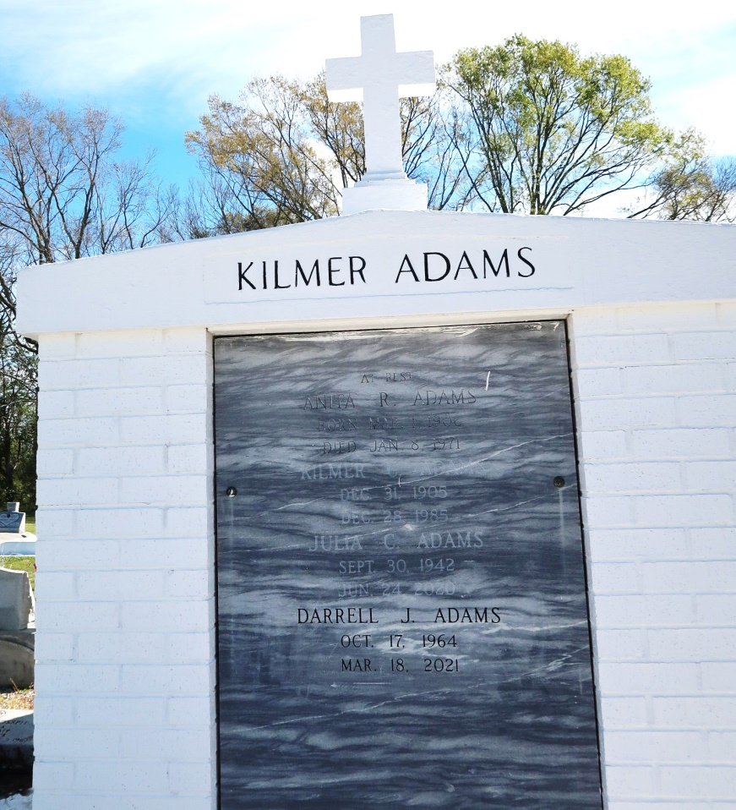

On Thursday, March 18, 2021, Darrell Joseph Adams transitioned from this earthly life and has now joined his mother, Julia Adams, who preceded him in death. He is survived by his father, Jerome Norwood Adams, Sr.; seven siblings, Darlene, Jerome Jr., Alexander, Francis (Darrell), Donell (Kenneth, Sr.), Darius (Arrika) and Jyron (Bianca); one Godchild, and a host of nieces, nephews, extended relatives and friends who will always cherish his memories.

A public walk-through viewing will be held on Friday, March 26, 2021 from 4 pm - 6 pm at Treasures of Life Funeral Services, 315 E. Airline Hwy., Gramercy, LA 70052. Relatives and friends of the family are invited to attend a Mass of Christian burial on Saturday, March 27, 2021 at St. Philip Catholic Church, 1175 LA-18, Vacherie, LA 70090. Recitation of the rosary at 10:40 am. Service will begin at 11 am. Father John Vu, Celebrant. Private burial. Final care entrusted to Treasures of Life Funeral Services.

To share condolences and thoughts, and to sign guest book, please visit [www.treasurefunerals.com.](http://www.treasurefunerals.com/) Due to CDC (COVID-19) guidelines and restrictions, masks and social distancing are required!

Published in The Times-Picayune from Mar. 24 to Mar. 27, 2021.

Contributed by Jane Edson