Haltron Adams, Jr.

January 29, 1934 - May 30, 2019

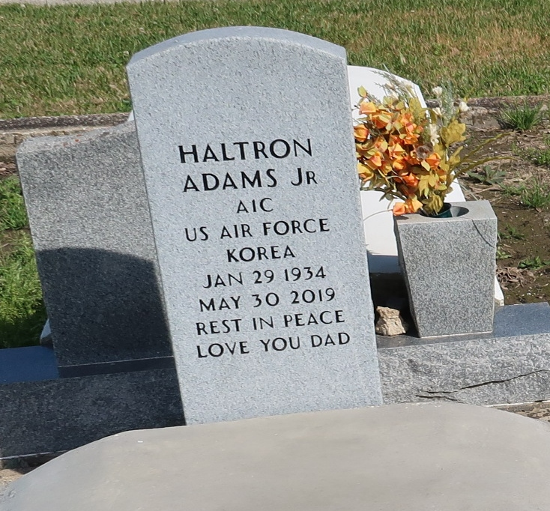

Haltron Adams, Jr., age 85, transitioned to his heavenly home on Thursday, May 30, 2019 at Ochsner-Kenner Hospital, surrounded by family and friends. He was a native of New Orleans, LA and longtime resident of Vacherie, LA. He was a retired basketball coach and history teacher from Alcee Fortier High School and his love of the sport never died.

His memories will forever be treasured in the hearts of his children Haltron III (GiGi), Rodwick (Christa), Sandra Grant (Alonzo) and Natasha Montgomery (Randall). He will also be missed by a host of grandchildren, great-grandchildren, other relatives and friends. He also leaves an empty place with his beloved cousin and “road dog” Norwood “Jerome” Adams. Haltron was preceded in death by his parents, Haltron Sr. and Golder Adams, his only brother, Donald Adams and his beloved wife, Linda Polk Adams.

We invite the congregation of First Baptist Church of Vacherie, Alcee Fortier Senior High School, and Ochsner Hospital’s Hospice Compassus Unit to join in a Celebration of Life on Wednesday, June 5, 2019 from First Baptist Church of Vacherie, 1244 Magnolia Heights St, Vacherie, LA. Rev. Dr. Johnnie B. Magee, Jr-Pastor and Officiant. Visitation 9:00am, service time 11:00am. Final viewing prior to service time. Interment to follow at St. Philip Catholic Church Cemetery, Vacherie, LA. Treasures of Life Funeral Services have been entrusted with his final care. 315 E. Airline Hwy, Gramercy, LA. 70090.

Treasures of Life Funeral Services, Gramercy, Louisiana