Alexander John Allen

March 14, 1935 – August 5, 2011

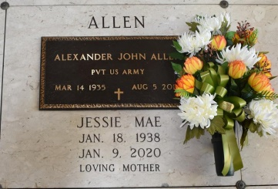

Alexander "Son, Beau James" Allen Sr. of Wallace, LA departed this Earthly Life on Friday, August 5, 2011 at his residence in Wallace, LA. He was a veteran of the U.S. Army. He was a retired employee of Colonial Imperial Sugar of Gramercy, LA after 39 years.

Beloved husband of Jessie Mae Cambre Allen for 52 years. Loving father of Rev. Alexander (Gio) Allen Jr., Finley (Myra) Allen, Quincy (Valerie) Allen, Malinda (Troy) Stewart, and Rodney (Mary) Allen. Brother of Marion (Prescott) Bailey, Nora (Warren) Pierre, Mable (Ernest) Harris, Leona (Charles) Dennis, and Washington (Ceonobia) Allen. Also survived by 13 grandchildren, 8 great-grandchildren, a host of nieces, nephews, other relatives and friends. Brother-in-law of James (Doris) and Hubert Cambre. He was preceded in death by his parents, Pearl L. Bastian and Thomas Allen Sr.; 2 brothers, Thomas Allen Jr. and Lowell Bastian; and a sister, Priscilla Mercedes Haydel.

Relatives and friends of the family, also Priest and Parishioners of St. Phillips Catholic Church and all neighboring churches, employees of Bayou Steel, Colonial Imperial Sugar, Acl, Turner, Zapp's, Orkin, St. James Youth Center, ADM, ISMG, Woods DayCare and NBS are invited to attend the Funeral Mass of Christian Burial at St. Phillips Catholic at 1175 Hwy. 18, Vacherie, LA on Tuesday, August 9, 2011 at 11:00 A.M. Visitation at the church will begin at 8:30 A.M. Rosary will begin at 10:00 A.M. Father Chris Decker, Celebrant. Entombment in church cemetery. In lieu of flowers, send donations to the [American Cancer Society](https://donate3.cancer.org/?campaign=legacy2&giftFirstName=Alexander&giftLastName=Allen&giftType=mem). Bardell's Mortuary of Mt. Airy, LA in charge. Information: 985-535-6837

Published by The Times-Picayune on Aug. 8, 2011.