William Johnny Banner Jr.

December 22, 1971 – September 5, 2021

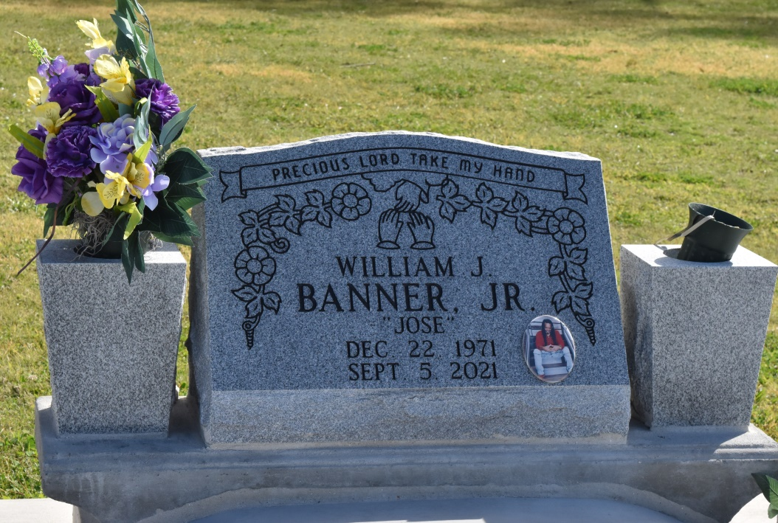

William Johnny Banner Jr. "Jose" left this world on September 5, 2021, in Kingsport, TN at the age of 49. A transplant of Wallace, LA. Jose nourished those around him with his kind heart, joyful spirit, and infectious laughter everywhere he went from Chicago to Tennessee. Jose was happiest cooking his favorite Louisiana dishes with his special Jose twist and loved to tell you about his cooking conquests, step by step. He reveled in the simple pleasure of sharing good times and stories with his family and friends.

He is survived by his wife, Taneshia Dunn Banner, his children, Jeremy Jones, and Tiara Marie Banner; his parents William Johnny Banner, Sr. and Harriett Populus Banner, his siblings Verdell Banner, Jocyntia Banner, and Joyceia Banner and a host of cousins and dear friends. Jose was most proud of his son Jeremy and his daughter Tiara who both brought him immense joy and happiness. His life was full of warmth, support, and laughter with his beloved wife and soulmate, Tish and the two were inseparable. He especially treasured his close and loving relationship with his parents Johnny and Harriett and would tell them so on his daily phone calls. His love and pride extended to his siblings. Their time was most often spent filled with laughter and fond memories of their childhood growing up together. Jose was surrounded by a community of beloved friends and dear cousins whose lives he enriched with his kindness and warm spirit. He will always be loved and forever missed.

Services will be held on Friday, September 10, 2021, at 4pm at St. James Catholic Church, 6613 LA-18 St. James, LA 70086. Rev. Matthew McCaughey presiding. The family will receive visitors from 2pm - 4pm for the viewing of the body followed by funeral service for family and close friends only due to Covid. To share condolences and thoughts, and to sign guest book, please visit: [www.treasurefunerals.com](http://www.treasurefunerals.com/).

Published by The Times-Picayune from Sep. 8 to Sep. 10, 2021.