Laura (Joseph) Baranco

May 25, 1934 - April 18, 2019

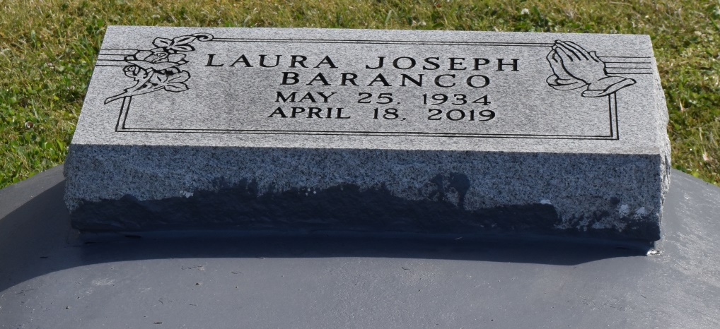

We loved her, yes we loved her, but GOD loved her best, and He has swiftly called her to Yonder’s Shinning Shores. The Golden Gates were opened: a gentle voice said, “Come” and with farewell unspoken, Laura calmly entered home.

Laura was born in Wallace, LA to the late Frank Joseph, Sr. and Viola Scineaux Joseph on May 25, 1934. Laura was a graduate of Magnolia High School and Xavier University at New Orleans in 1958. Laura was employed and retired from the offices of Family Support, as a Social Worker and Supervisor in the New Orleans Mid-City office. She enjoyed spending her leisure time being a true New Orleans Saints fan and a great supporter of her golf icon, Tiger Woods. She was a faithful Alumni of Xavier University at New Orleans where she was a sincere contributor and participant of many of the University’s events. She was devoted parishioner to St Joseph the Worker Catholic Church for a number of years.

She leaves to cherish her precious memories, her sister Frances J. DeGruy, and a host of nieces, nephews and cousins. Laura was preceded in death by her brothers, Lloyd, Boyle, and Frank Joseph, Jr.

We welcome all parishioners of St. Joseph the Worker Roman Catholic Church, all family and friends to join us to say final farewells. Mass of Christian Burial will begin at 10am on Saturday, April 27th at Saint Joseph the Worker Roman Catholic Church located, 455 Ames Boulevard, Marrero, LA 70072. Recitation of the Rosary at 9am. Visitation will begin at 8am. Interment will be at St. Philip Cemetery in Vacherie, LA. Final care entrusted to Treasures of Life Funeral Services, 315 E. Airline Hwy, Gramercy, LA 70052.

Treasures of Life Funeral Services, Gramercy, Louisiana