Joseph Barnes Jr.

November 10, 1931 – November 26, 2013

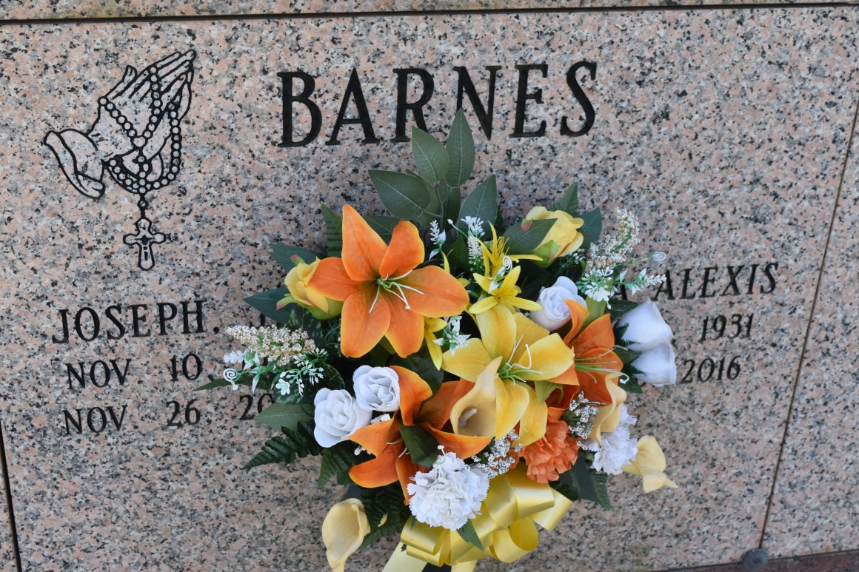

Joseph Barnes, Jr., passed away on Tuesday, November 26, 2013, at the age of 82. Son of the late Vivian and Joseph Barnes, Sr. Husband of Olga Alexis Barnes. Father of Desmond (Shannon) Barnes and Stephanie Aubert. Also survived by a host of sisters, cousins, nieces, nephews, grandchildren, other relatives and friends.

Funeral services will be held at St. Phillip Catholic Church, 1175 Highway 18, Vacherie, La. on Tuesday, December 3, 2013 for 11:00 a.m. Visitation will be from 9:00 a.m. until time of service. Father Christopher Decker will be officiating. Interment will be at St. Phillip Catholic Church Cemetery, Vacherie, La. Funeral entrusted to The Baloney Funeral Home, LLC., 1905 W. Airline Highway, Laplace, La., 985-224-8460. Condolences can be expressed at [www.baloneyfuneralhome.com.](http://www.baloneyfuneralhome.com/)

Published by The New Orleans Advocate from Nov. 30 to Dec. 1, 2013.