Bernadine (Grow) Bartholomew

July 24, 1934 – February 14, 2016

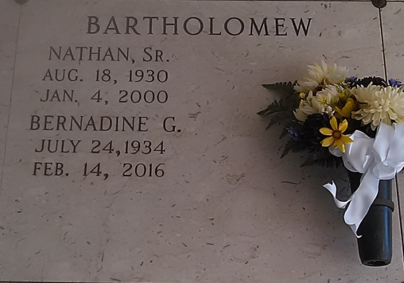

Photo by TMB

Bartholomew - Bernadine Grow Bartholomew, 81, a resident of Vacherie, LA passed away at home on Sunday, February 14, 2016. Wife of the late Nathan Bartholomew Sr. Mother of Nathan Jr. (Avis), Donald (Joan) and Sandy Warren (Gary); grandmother of Donald Jr., Jaimie, Briana, Carlin, Spencer and Grant. Also survived by her sister Pearl Clark and sisters-in-law Florida Grow and Dee Grow; and a host of relatives and friends. She was preceded in death by her parents Aurelian and Augustine Grow; and brothers Pierre, George, John, Aurelian Jr. and Lazin. Relatives and friends of the family, also priest and parishioners of St. Philip Catholic Church and neighboring churches are invited to attend a mass of Christian burial on Sat. Feb. 20, 2016 at 11:00am at St. Philip Catholic Church, 1175 Hwy 18, Vacherie, LA. Father Christopher Decker, Celebrant. Visitation at the church after 9:00am. Entombment at the church mausoleum. Treasures of Life, Center for Life Funeral Services entrusted with final disposition. 315 E. Airline Hwy, Gramercy, LA 70052

Times-Picayune, The (New Orleans, LA)

Thursday, February 18, 2016