Nathan Bartholomew Sr.

August 18, 1930 – January 4, 2000

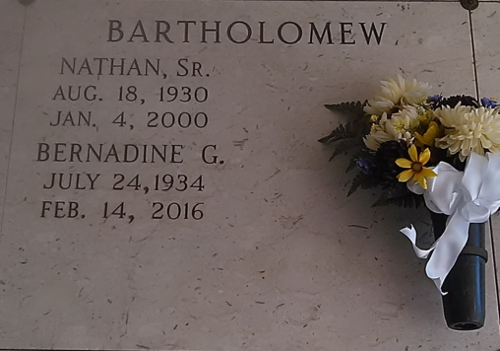

Photo by TMB

VACHERIE - Nathan A. Lightning Bartholomew Sr., 69, a native of Edgard and resident of Wallace, died Jan. 4. He was the husband of Bernadine Grow Bartholomew and father of Nathan Jr., Sandy and Donald Bartholomew. He was also the son of the late Mitchell and Corinne Coleman Bartholomew and brother of Hilda Roussel and the late Muriel Williams, Ruth Simon and Melba Mathieu. He is also survived by six grandchildren. Services are today at 10 a.m. at St. Philip Catholic Church, Vacherie, with interment at the church mausoleum. Visitation starts at 8 a.m.

L'Observateur (La Place, LA)

Saturday, January 8, 2000

Contributed by Jane Edson