JoAnn Bastian

October 1, 1950 - May 28, 2021

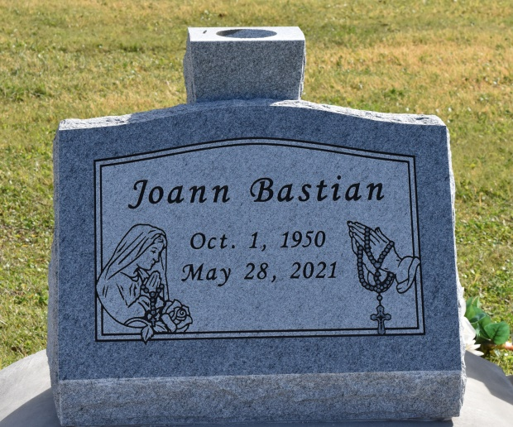

JoAnn Bastian, a lifelong resident of Wallace, Louisiana, passed away on Friday, May 28, 2021, at the age of 70. She was born on October 1, 1950 to her late parents, Hayward Thomas and Rosemary Populus Bastian, Sr. JoAnn attended school in St. John the Baptist parish and was a graduate of Second Ward High School's Class of 1969. She was known as a devout Roman Catholic. She attended mass regularly and prayed the rosary daily. JoAnn enjoyed playing BINGO in her spare time. JoAnn would often be seen traveling with her BINGO group for various activities where she would bring her mother along with her. She also loved making candied apples and popcorn balls for her nieces.

JoAnn is survived by her seven siblings: Geary Bastian, Sr. (Alberta), Roy Bastian (the late Janice), Phyllis Clark (Mallory), David Bastian, Sr. (Vanessa), Charles Bastian, Bernadette Bastian, and Elizabeth Thompson (Gregory); along with a host of nieces, nephews, other relatives and friends. She is preceded in death by her parents, Hayward and Rosemary Bastian, Sr., and her brother Hayward Bastian, Jr. JoAnn will be greatly missed by many.

A public walk-through visitation will be held on Thursday, June 3, 2021, at Treasures of Life Funeral Services, 315 E. Airline Hwy., Gramercy, LA 70052 from 10AM – 12PM. A Mass of Christian Burial will be held at 1PM at St. Philip Catholic Church 1175 LA-18, Vacherie, LA 70090. Interment to follow at St. Philip Catholic Church Cemetery in Vacherie, LA. Final care entrusted to Treasures of Life Funeral Services. To share condolences and thoughts, and to sign guest book, please visit: www.treasurefunerals.com. Due to CDC (COVID-19) guidelines and restrictions, masks and social distancing are REQUIRED!!

Treasures of Life Funeral Services, Gramercy, Louisiana