Rosemary (Populus) Bastian

April 9, 1927 - August 14, 2019

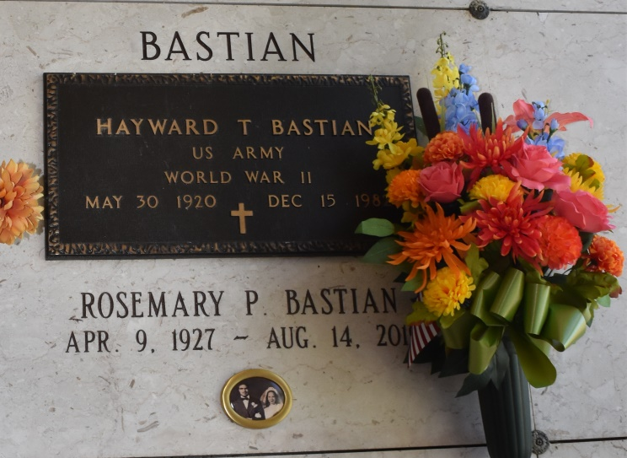

Rosemary P. Bastian was born on April 9, 1927 in Wallace, Louisiana to Joseph Victor Populus and Cordelia Brown Populus. After graduating from Xavier University of Louisiana, she began her career as a teacher at Wallace Rosenwald School. While working as a teacher, she met and married her husband, the late Haywood Thomas Bastian, Sr. From this 36 year union, God blessed them with nine children: Geary Bastian, Sr. (Alberta), Jo Ann Bastian, Roy Bastian (the late Janice), Phyllis Clark (Mallory), Haywood Bastian, Jr., David Bastian, Sr. (Vanessa), Charles Bastian, Elizabeth Thompson (Gregory), and Bernadette Bastian. As a devout Roman Catholic, she was very active at St. Philip Catholic Church all of her life by serving as a Eucharistic Minister, Lector, and church caretaker. She ensured that the church was always ready to receive its parishioners, in a comfortable setting, for all religious occasions. In addition, following in the footsteps of her mother, she was a member of the Knights of Peter Claver, Inc. Ladies Auxiliary Court No. 45 (Louisiana) for 70 plus years. However, her services was not limited just to St. Philip, she was well-known in several Roman Catholic churches along the River Road. Rosemary enjoyed time with her family and friends. Most of all, she enjoyed her daily devotion to the Blessed Mother and weekly visits to Our Lady of Peace Roman Catholic Church Adoration Chapel. Rosemary left this earthly life at the age of 92 on August 14, 2019 to join her beloved husband, her dear parents, and her siblings: Hamilton, Anthony, Hayward, and Daniel Populus, Lydia Bastian, Marquarite Gorospe, Enola Francis, and Margie Oubre. She leaves to cherish her memories: 9 children, 17 grandchildren, and a host of nieces, nephews, other loving relatives, and many friends. A mass of Christian burial will be held at St. Philip Catholic Church, 1175 Highway 18, Vacherie, LA on Saturday, August 17, 2019 at 11 a.m. with Father Vincent J. Dufresne officiating. Visitation will begin at 9 a.m. followed by the Rosary at 9:30 a.m. Entombment at St. Philip Catholic Church Cemetery. Final care has been entrusted to Treasures of Life Funeral Services, 315 E. Airline Hwy Gramercy, LA 70052.

Treasures of Life Funeral Services, Gramercy, Louisiana