Alma (Bastian) Becnel

March 11, 1917 – April 16, 2008

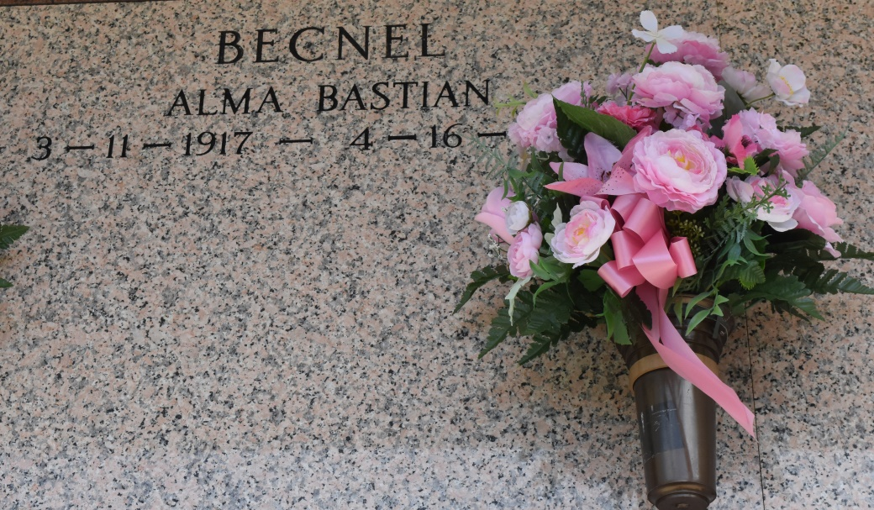

Alma B. Becnel, of Wallace, LA at Thibodaux Regional Medical Center, Thibodaux, LA, on Wednesday, April 16, 2008 at 12:05 p.m. Beloved wife of the late Victor J. (Peno) Becnel. Daughter of the late Emile and Agnes Theard Bastian. Mother of James, Victor Jr., Glenn, Perry and A. Jean Becnel, Irma B. Middleton, Jacqueline B. Bush, Deadria B. Mathieu and Elise B. Kirkland. Also survived by 4 daughters-in-law, 2 sons-in-law, 37 grandchildren, 59 great-grandchildren, 2 sisters, a host of nieces, nephews, other relatives and friends. A native and resident of Wallace, LA. Age 91 years.

Relatives and friends of the family; also priest and parishioners of St. Phillip Catholic Church, Vacherie, LA and neighboring churches; employees of St. John Parish Courthouse, Dow St. Charles, St. Helena Parish School System and Community Care Hospital, New Orleans, LA are invited to attend a Mass of Christian Burial on Saturday, April 19, 2008 at 11:00 a.m. from the St. Phillip Catholic Church, Vacherie, LA. Father Louis Oubre, celebrant. Entombment Church Mausoleum. Visitation at the Church after 9:00 a.m. Saturday. THE BALONEY FUNERAL HOME, LLC 399 Earl Baloney Dr., Garyville, LA 70051 Information: (985) 535-2540 in charge of arrangements

Published by The Times-Picayune (LA) on Apr. 18, 2008.