Velma (Loup) Biondello

February 11, 1911 – April 14, 1992

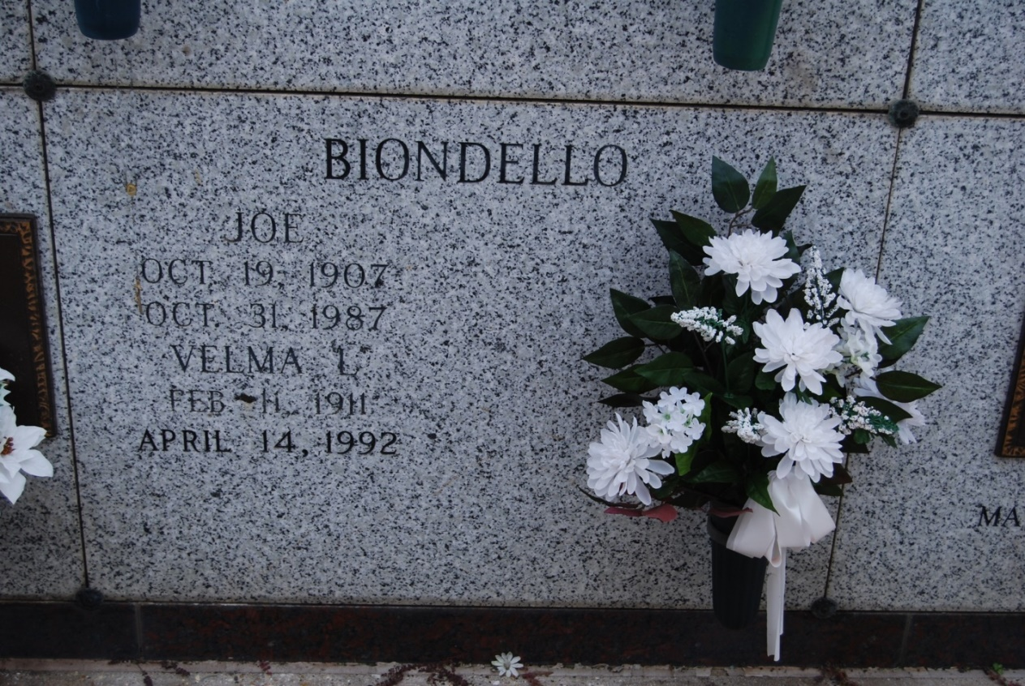

Photo by Kerry Keller

BIONDELLO, VELMA LOUP

Died 4 p.m. Tuesday, April 14, 1992, at Our Lady of the Lake Rebional Medical Center. She was i1, a native of Vacherie and a resident of Baton Rouge. She was a retired schoolteacher. Visiting at St. Philip Catholic Church, Vacherie, 9 to 11 .m. Thursday. Entombment graveside services in church mausoleum, conducted by the Rev. Salvador “Butch” Moran. Survived by two sisters, Clemence Waguespack and Louella Burch, Both of Vacherie; a brother, Roy Lup, Sulphur; nieces and nephews. Preceded in death by husband, Joe Biondellow; parents, Emielie Roussel and Pascal Loup; a sister, Lucilla Loup; and three brothers, Felicien, Nemour and Ferdidnad Loup. She was a member of St. Louis King of France Catholic Church and Altar Society. Rabenhorst Funeral Home East in charge of arrangements.

Morning Advocate, Baton Rouge, LA

Thursday, April 16, 1992, p. 6-B