Mary Ann Waguespack Borne
July 03, 1929 - December 30, 2023

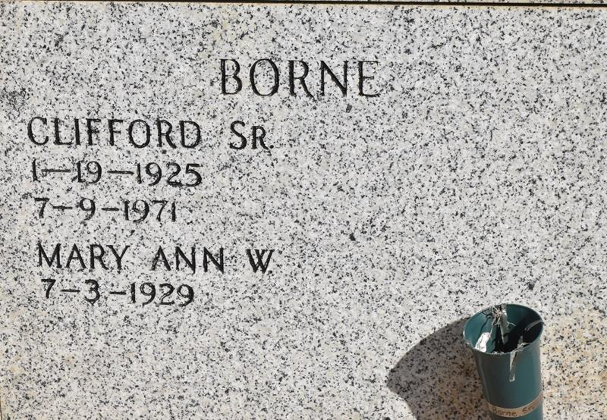

Mary Ann Waguespack Borne a resident of Vacherie , passed away December 30, 2023 at the age of 94.
Beloved wife of the late Clifford Borne, Sr. Loving mother of Clifford Borne, Jr. (Susan), Sidney Borne, Sr. (Deborah), Jane Chauvin (Raymond), Eva Knight (Tim), Betty Danos (Jerome), James Borne (Tricia), and the late Lorraine Delk (Steve). Grandmother of 19. Great grandmother of 32. Daughter of the late Cecile Schexnaydre Waguespack and Francis Anthony Waguespack, Sr. Sister of Elaine Legendre (the late Percy), Thomas Waguespack (the late Vivian), Geraldine Waguespack (the late Herman), Charles Waguespack (Rosalie), Barbara Wood (the late Jerry), Wayne Waguespack (Judy), the late Deacon Francis Waguespack,Jr. (the late Louise), the late Shirley Waguespack (the late George), the late Albert Waguespack, Sr. (Jackie), the late Cecile Hymel (the late Burchman) and the late Allen Waguespack (Mary Ellen Gravois). Also survived by numerous nieces, nephews, and cousins.
Relatives and friends are invited to attend the Visitation and Funeral Mass at St. Philip Catholic Church, 1175 LA-18, Vacherie, LA on Wednesday, January 3, 2024. Visitation at church from 9:00 a.m. to 11:00 a.m. followed by a Funeral Mass at 11:00 a.m. Interment in St. Philip Church Cemetery, Vacherie, LA.
The family would like to thank Haydel Hospice from Houma for their support and care in mom's final days. The family would also like to thank Marcia, Cheryl, Catherine, and Lena for the excellent care they provided.

Rose Lynn Funeral Home, Lutcher, Louisiana
January 2, 2024

