Lori Ricard Carnovale
July 18, 1955 - December 4, 2023

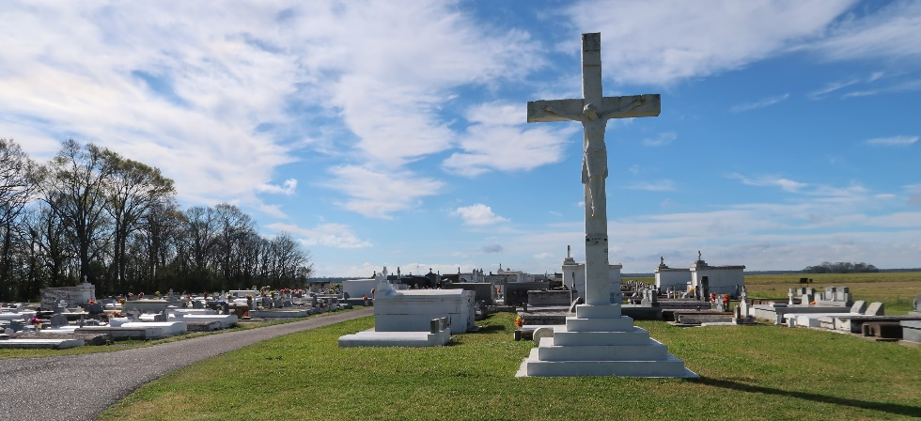

Lori Ricard Carnovale passed away on Monday, December 4, 2023 at the age of 68. She was born in New Orleans and a resident of Vacherie, LA.
Beloved mother of Kristin Green (Brian). Grandmother of Alexis and Joseph Green. Daughter of the late Emile Ricard, Jr. and Helen Rock Ricard. Sister of Shaun Saizan (Darrel), Mark Ricard (Aw), Avis Sherman (Leo), and the late Cheyrl Floyd (Ira). Also survived by numerous nieces, nephews, and cousins.
Relatives and friends are invited to attend the Visitation and Funeral Mass at St. Philip Catholic Church, 1175 LA-18, Vacherie, LA on Tuesday, December 12, 2023. Visitation at church from 9:00 a.m. to 11:00 a.m. followed by a Funeral Mass at 11:00 a.m. Interment in St. Philip Church Cemetery, Vacherie, LA.
To view or sign the online guest book, please visit www.roselynnfuneralhome.com

Rose Lynn Funeral Home, Lutcher, Louisiana
December 9, 2023

