Roland Joseph Cazenave Jr.

June 21, 1938 - December 16, 2020

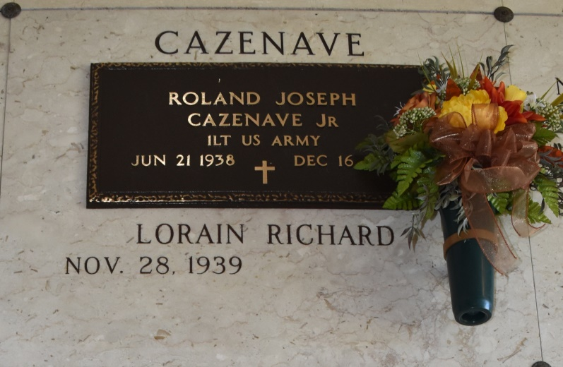

Roland Joseph "R.J." Cazenave, Jr. was born on June 21, 1938 and passed away peacefully on December 16, 2020 at the age of 82.

  He was a native and resident of Vacherie, LA. He is survived by his beloved wife of more than sixty years, Lorain Richard Cazenave and sons:  Daryl (Andrea), Dean (Stephanie) and Dennis “Doodie” (Kim). He is survived by five siblings, Carolyn C. Potter, Phyllis C. Arcement, Michael Cazenave (Cherlyn), Sandra C. Graugnard (Francis), and James “Jimmy” Cazenave (Cheryl), and many beloved nephews and nieces. He leaves behind seven beloved grandchildren:  Kandis, Christopher, Jordan, Sarah, Connor, Samantha and Cole Cazenave.

He is preceded in death by his parents, Roland Cazenave, Sr., and Stella Webre Cazenave, and an infant grandson, Gerard Cazenave.

He was a graduate of St. James High School (1956), and Louisiana State University (B.A., 1960).  He received his commission as an officer in the U.S. Army in 1960, and served 2 years on active duty as Second Lieutenant, including assignments with the Air Defense Artillery at Ft. Bliss, Texas, and with the 35th USA Artillery Detachment in Germany.  He was a long-time member of the Knights of Columbus and of the St. Philip Hunting Club. He was a parishioner and longtime volunteer at St. Philip Catholic Church.   He most enjoyed spending time with family and friends, including vacations with his wife, children and grandchildren, and spending time with friends at St. Philip Hunting Club’s camp.  He worked for Dupont for 33 years before retiring from the LaPlace facility.

A rosary in his honor will be recited on December 19, 2020 at St. Philip Catholic Church in Vacherie, LA at 10:30 a.m. followed by a Mass of Christian Burial at 11:00 a.m.  Due to CDC Regulations, the family will not be having a visitation. Interment will follow after services at St. Philip Cemetery. ROSE LYNN FUNERAL SERVICES, 1870 Cabanose Ave., Lutcher, LA is in charge of the arrangements.  In lieu of flowers, donations to your favorite charity are requested.

Rose Lynn Funeral Home, Lutcher, Louisiana