Maude Chopin

December 7, 1914 – March 19, 2008

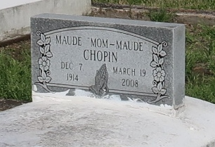

Maude (Maw Maude) Chopin at her residence on Wednesday, March 19, 2008 in Vacherie, La. departed this life. A resident of Wallace, La. for 77 years and of Vacherie for 16 years. Age 93 years. Wife of the late Marshall Chopin for 70 years. Mother of Evelyn Bethancourt and Lester (Vivian) Chopin. Sister of the late Alfred Peters. Sister in law of Leah Steward. Also survived by 8 grandchildren, 16 great grandchildren, 7 great great grandchildren, a host of nieces, nephews, cousins and friends.

Funeral services will be held on Wednesday, March 26, 2008 at 11:00am from the St. Phillip Catholic Church, 1175 Hwy. 18, Vacherie, La.; Father Louis Oubre celebrant. Recitation of the rosary at 10:00am. Visitation at the church after 9:00am. Interment church cemetery. The Baloney Funeral Home LLC 399 Earl Baloney Dr., Garyville, La. 985-535-2540 In Charge of Arrangements

Published by The Times-Picayune (LA) on Mar. 25, 2008.