Dardnella Marie Clark

December 29, 1954 - January 5, 2018

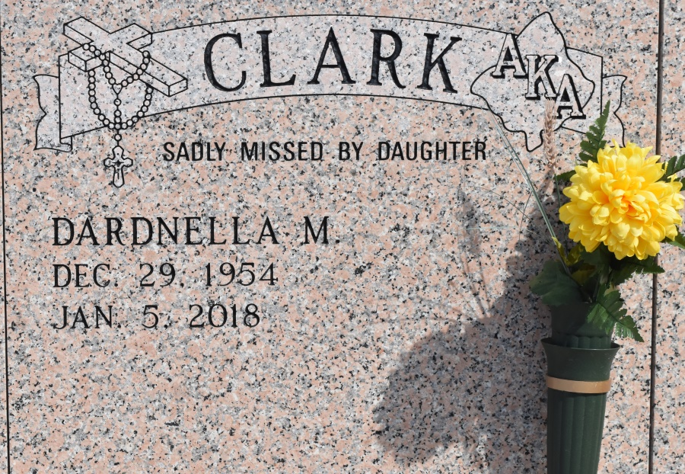

Dardnella Marie Clark, a retired educator and lifelong resident of Reserve, LA died unexpectedly on January 5,2018 at 63 years of age.  
 Dardnella, affectionately known as “Shug" was born on December 29,1954 in Wallace, LA to Winnie Schexnayder Clark and the late Shelton Clark Jr. She was baptized into the Catholic faith at St. Philip Catholic Church in Vacherie, La. She was the first of four daughters and the second of seven children.  
At an early age, Dardnella exhibited a passion for knowledge and began her extended educational journey at Wallace Rosenwald Elementary. She completed her elementary education at Our Lady of Grace school when her family moved to Reserve. She then attended Leon Godchaux High School where she graduated with the class of 1972.  
 Her love for children was a driving factor in her decision to further her studies at Southern University A&M in Baton Rouge where she received her Bachelor's of Arts in Education, Masters in Education, +30 in Education, Masters in Counseling, and +30 in Counseling and Supervision.  
Dardnella entered the work force in her hometown of Reserve, LA in 1976 as a kindergarten teacher for St. John the Baptist Parish school system. She remained employed there for 36 years until her retirement in 2012. During her tenure, she was not only a teacher but a disciplinarian as well as a counselor.  
 Whether she was known as Ms. Clark or Mrs. Steib, one thing all her students knew was that she took education VERY seriously. No one knew this better than her nieces and nephews that Shug had the pleasure of teaching. Many of whom were shown tough love by her paddle.  
 Dardnella was the first Queen of the Krewe of Agape Social Club in 1988 where she reigned alongside her brother Colbert “Bot" Clark. Dardnella was also a proud member of Alpha Kappa Alpha Sorority Incorporated. Although not active, everyone knew she LOVED her sorority.  
 On February 10, 1995 her love for children came full circle with the arrival of her only child Denair Marie Clark. She was a devoted mother and they shared a bond that was unbreakable. Her proudest moment was being able to watch Denair walk across the stage receiving her Bachelor's of Arts degree from the University of Louisiana Lafayette on December 15, 2017.  
Even though she retired, Dardnella found a way to continue to devote her time and effort to kids by doing after school tutoring. She was also selected to serve as a member of the St. John Parish Library Board where she held the position of treasurer. In her spare time, she enjoyed shopping, baking, and spending time with her family and friends.  
 Dardnella leaves to cherish her memories her daughter Denair Marie Clark of Reserve, her mother Winnie Schexnayder Clark of Reserve, her siblings Robin C.(Huey) Fleming of Reserve, Theron (Rhonda) Clark of Laplace, Colbert (Aline) Clark of Paulina, Karen C. (Bernell) Tassin of Reserve, and Kim Clark of Reserve; extended siblings Nita (Larry) Jackson Sr. And Don (Muriel) Labiche; her nieces and nephews Janell (Elliot) Jessie, Terrell (Trellis) Fleming, Darnell (Chrisell) Fleming, Karanell Tassin, Therionna Clark, Samuel (Breanna)Batiste, Trinell (Keith) Tassin- Evans, Trinata Clark, Bernell Tassin Jr., Kyle Clark, Avonnti Rance, Theron Clark Jr., Tae'Lair Clark; her godchildren Copeland Griffin, Wayne Boudoin, Shawn Frazier, Ryshique Williams, Nicole Christmas, Cara Schexnayder, Trinata Clark, Angelle Johnson, and Branae Johnson; devoted friend Pamela Linton, Margie Snyder, Sherial Magee, Valencia Joseph, Cynthia Houston, Gina Batiste and a host of great nieces and nephews, uncles, aunts, and other relatives.  
 St. John Parish School Board, St. John Parish Library Board, Leon Godchaux High School class of 1972 and members of Alpha Kappa Alpha Sorority Incorporated, and parishioners of Our Lady of Grace Catholic church are invited to attend a Mass of Christian Burial on Wednesday, January 10, 2018 from Our Lady of Grace Catholic Church, 772 LA 44, Reserve, LA. Reverend Christopher Amadi, Celebrant. Visitation from 8:00am until service time at 10:00am. There will be a gathering of family and friends from 5:00-7:00pm on Tuesday, January 9, 2018 at Treasures of Life Funeral Services, 315 E. Airline Hwy, Gramercy, LA, who have been entrusted with her final care.

Treasures of Life Funeral Services, Gramercy, Louisiana