Mildred Lathan Clark

October 5, 1936 – June 27, 2019

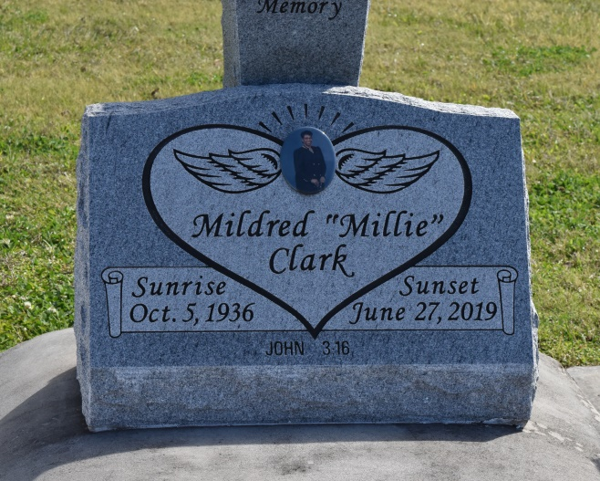

Mildred Lathan Clark, on Thursday June 27, 2019 at 6:45 am departed this life in the comfort of her home surrounding by her family. Beloved daughter of the late Juanita Ellis and Albert Becnel of Vacherie, Louisiana. The wife of the late Lawrence Andrew Clark Sr. Mother of Myron P.Clark (Sarletha), Demetriel C. Walker (Larry), Tanjia Love Berry (David), Sabrina M. Byes (Jules), Kirt Clark (Wanda), the late Lawrence A. Clark Jr. (Melvina), Gregory J. Clark, and Kevin Clark. The sister of June Walker and sister-in-law of the late Harry Walker. Also survived by 23 grandchildren, 36 great-grandchildren, a host nieces, nephews, other relatives and friends.

Relatives and friends of the family, also employees of Woldenberg Village Assisted Living Center, Oakwood Corporation, and District Security, Orleans Parish School Board System, St. Anthony Catholic Church, All Saints Catholic Church, Fischer Community Church, St. Stephens Baptist Church, and other neighboring churches are invited to attend a Mass of Christian Burial at St. Anthony Catholic Church, 924 Monroe Street, Gretna, Louisiana 70053 on Saturday, 6 July 2019. Visitation begins for 10 a.m. followed by Rosary and Celebration of Life, followed by Mass of Christian Burial at 12 noon. Interment in St. Phillip Catholic Church Cemetery, 1175 LA-18, Vacherie, Louisiana 70090. Final care entrusted to Treasures of Life Funeral Services, 315 East Airline Hwy, Gramercy, LA 70052.

Published by The Times-Picayune (LA) from Jul. 2 to Jul. 6, 2019.