Stafford Clark

March 21, 1932 – Marach 10, 2019

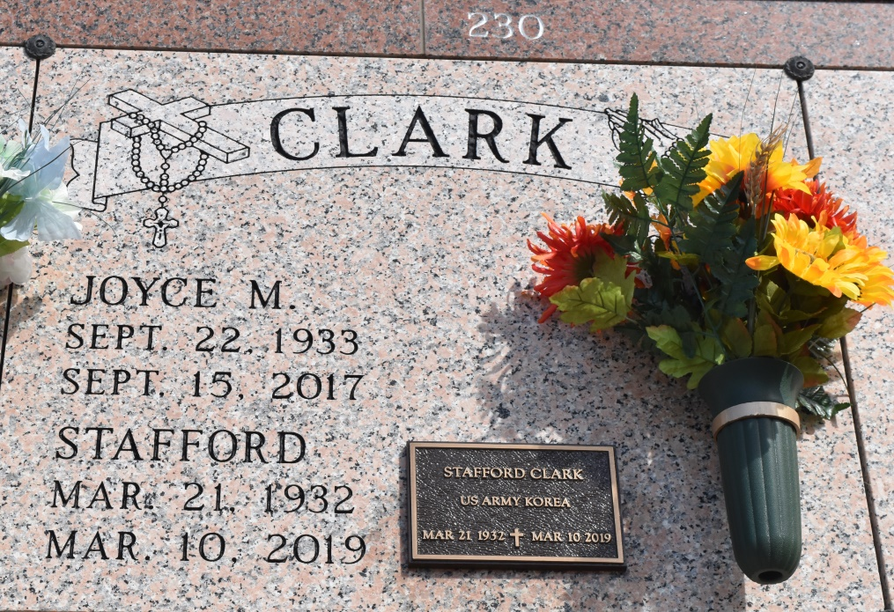

Stafford ""Sticka"" Clark entered into eternal life on March 10, 2019 at the age of 86. He was married to the late Joyce Jackson Clark for 59 years.

He leaves behind his memories to be cherished by his loving daughter, Deanna Clark Thomas and granddaughter, Christen Thomas. He served in the Korean War from 1952 - 1954.

Family, friends, employees of Kaiser Aluminum, Modern Hospice and Stand-Up-Open MRI are invited to celebrate his homecoming and a Mass on Friday, March 15, 2019 from Our Lady of Grace Church, 780 Hwy 44; Reserve, LA 70084 at 10:00 am. Father Christopher Amadi, Celebrant. Visitation begins at 8:15 a.m. Rosary begins at 9:15 a.m. Entombment following at St. Philip Catholic Church, 1175 LA 18; Vacherie, LA 70090. Final care entrusted to Treasure of Life Funeral Services, 315 E. Airline Hwy, Gramercy, LA. 70052.

Published by The New Orleans Advocate from Mar. 14 to Mar. 15, 2019.