Bridget Ann (Legendre) Darlington

September 22, 1972 – June 9, 2003

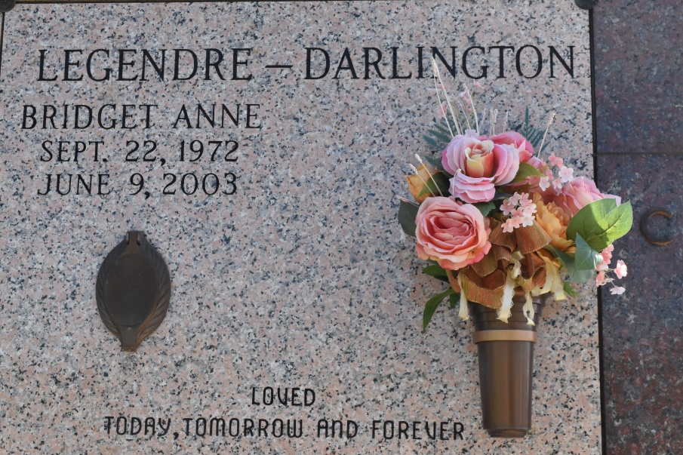

Photo by Team T Lo

Bridget Anne Legendre Darlington, after a courageous, determined and well-fought battle with cancer, age 30 years, a native of Vacherie, LA and resident of Baton Rouge, LA, went home to be with her Heavenly Father on Monday, June 9, 2003.

She is survived by: her loving husband, Andew Carey Darlington; her parents: Percy J. Legendre, Jr. and Elaine Waguespack Legendre of Vacherie, LA; brothers and sisters-in-law: Percy Legendre III and Lynn Hoffman Legendre of Tampa, Florida and Reginald Legendre and Nancy Marshall Legendre of DeRidder, LA; sisters and brothers-in-law: Lynette L. and Mark Eliser of St. Amant, LA, Angela L. and William 'Colt' James, Jr. of Alexandria, LA, Natalie L. and Tony Harper of Baton Rouge, LA, Elaine L. and John Curley of Alexandria, LA, Lenore L. and Gregory Charlton of Bluffton, South Carolina and Helen L. and Edward Bohan of Bedford, New Hampshire; sixteen nieces and nephews; her paternal grandmother, Vernice Peltier Legendre of Westwego, LA; and numerous aunts, uncles and cousins. She is also survived by: her mother-in-law, Marie Galloway of Baton Rouge, LA; sister-in-law, Shannon Galloway of Dallas, Texas and father-in-law, William Darlington of Marina Del Rey, California.

Preceded in death by: maternal grandparents: Francis and Cecile Schexnayder Waguespack, Sr., of Vacherie, LA and paternal grandfather, Percy J. Legendre, Sr. of Westwego, LA. A native of Vacherie, LA, Bridget and her husband Andrew have lived in Albuquerque, NM; Tampa, FL; Dublin, OH and Bedford, NH.

She graduated from E.D. White Catholic School in Thibodaux, LA and Louisiana State University in Baton Rouge, LA with a Bachelor of Science degree in Quantitative Business Analysis. She was most recently the Research Director for Grubb & Ellis / Coldstream Real Estate Advisors, Inc. in Bedford, New Hampshire. She was formerly a Research Analyst for the Louisiana Legislative Fiscal Office in Baton Rouge.

Family and friends are invited to attend funeral services. A Mass of Christian Burial will be celebrated at 11 am on Wednesday, June 11, 2003 at St. Philip Catholic Church, Vacherie, LA. Interment to follow in St. Philip Mausoleum. Visitation will be held at the Church on Tuesday from 7 pm until 9 pm, and again on Wednesday, from 9 am until 11 am. Celebrant will be Rev. Louis E. Sklar, III. In lieu of flowers, donations can be made to the Susan G. Komen Breast Cancer Foundation and E. D. White Catholic High School Memorial Fund. Arrangements under the direction of ALEXANDER FUNERAL HOME, 2208 Jefferson Hwy., Lutcher, LA. Information 225-869-5553.

Published by The Times-Picayune from Jun. 10 to Jun. 11, 2003.