Paula Annette (Adams) Dennis
October 5, 1960 – August 18, 2023

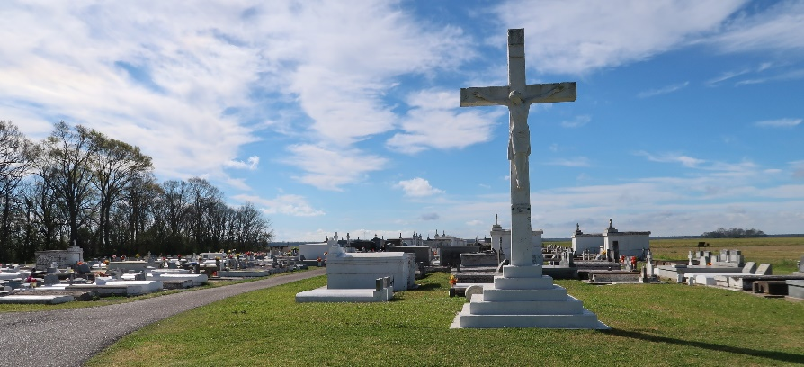

Paula Annette Adams Dennis of Vacherie, Louisiana, known to many as "Mrs. Paula", was born on October 5, 1960, to the late Mildred and Roland Adams Sr. of Wallace, LA. Paula, a dedicated wife, mother, aunt, sister, sister-in-law, daughter-in-law, cousin, and friend to many, passed away on August 18, 2023 at the age of 62.
A dedicated teacher at Sixth Ward Elementary School in Vacherie, La for twenty years, Paula retired from the St. James Parish School System in 2016, then became a substitute teacher, and lastly an employee of St. James Parish Library. She was a member of St. Philip Catholic Church, where she taught catechism for a number of years. She graduated from West St. John High School Class of '79 and received a B.S. in Early Childhood from Southern University and A&M College. She was a member of the Phi Sigma Omega Chapter (1988) of Alpha Kappa Alpha Sorority Inc. in Gonzales, LA, the St. James Parish Retired Teachers Association, and the Krewe of Agape. Paula was an advocate of education and loved her teaching career and students and would go above and beyond to help them.
She was passionate about spending time with her family both immediate and extended anytime she could. During holidays she would cook many loved and requested meals for all her family to enjoy and share laughter and good times around. She was a very loving mother and mother figure to many and was selfless with her acts of care, kindness, and love. Paula was never one to miss the opportunity to spark a conversation and with those conversations she made sure to know how you, your parents, children, and whoever else were doing.
Paula and Herbert Dennis Sr. were united in Holy Matrimony on May 20, 1989 at St. Philip Catholic Church; to this union three children were born; Herbert Dennis Jr., Ashton P. Dennis, and Madison V. Dennis. Survived by spouse; Herbert Dennis Sr. of Vacherie, LA, three sons; Herbert Dennis Jr. of Houston, Tx., Ashton P. Dennis of Baton Rouge, LA., and Madison V. Dennis of Vacherie, LA. Sister; Patricia Moore of Baton Rouge, LA, four brothers: Clyde Adams (Lucinda) of Boutte, LA., Wayne Adams (Stephanie) of Harvey, LA, Brian Adams of Baton Rouge., and Adrian Adams of Vacherie, LA. Father-in-law; Horace Dennis Sr. of St. James, LA, two sisters-in-law; Elaine Jasmin (Joseph) of St. James, LA., and Eva Ellis (Terry) of Fredrick, MD., brother-in-law; Harold Dennis (Rose) of Slidell, LA., and a host of nieces, nephews, great nieces, great nephews, relatives, and friends.
Proceeded in death by her mother; Mildred Adams, father; Roland Adams Sr., sister; Marchand Adams, brother; Roland Adams Jr., nephew; Colby Adams, niece; Enjoli Adams, mother-in-law; Ethel M. Dennis, sister-in-law; Evelyn Dennis, brother-in-law; Horace Dennis Jr., grandparents, several aunts and uncles.
Relatives and friends are invited to attend a public viewing on Friday, August 25, 2023, at Treasures of Life Funeral Services, 315 E. Airline Highway, Gramercy, LA 70052 from 5:00 pm - 7:00 pm. A celebration of life honoring Paula Annette Adams Dennis will be held on Saturday, August 26, 2023, at St. Philip Catholic Church, 1175 La. Highway 18, Vacherie, LA. Rosary will be recited from 9:00 am - 9:30 am. Visitation is from 9:30 am - 10:45 am. Service will begin at 11 am. Interment to follow at St. Philip Catholic Church.

Treasures of Life Funeral Services, Gramercy, Louisiana
August 23, 2023

